iSSUE: 9

The World of birds

dATE: 21st october 2014

Welcome
qUICK fACT
Did you know that the goldfinch is one of the most common garden birds in the UK. On average in the UK 20 years ago there were only 0.5 goldfinch per garden, now there are on average 1.8per garden in the UK!!! 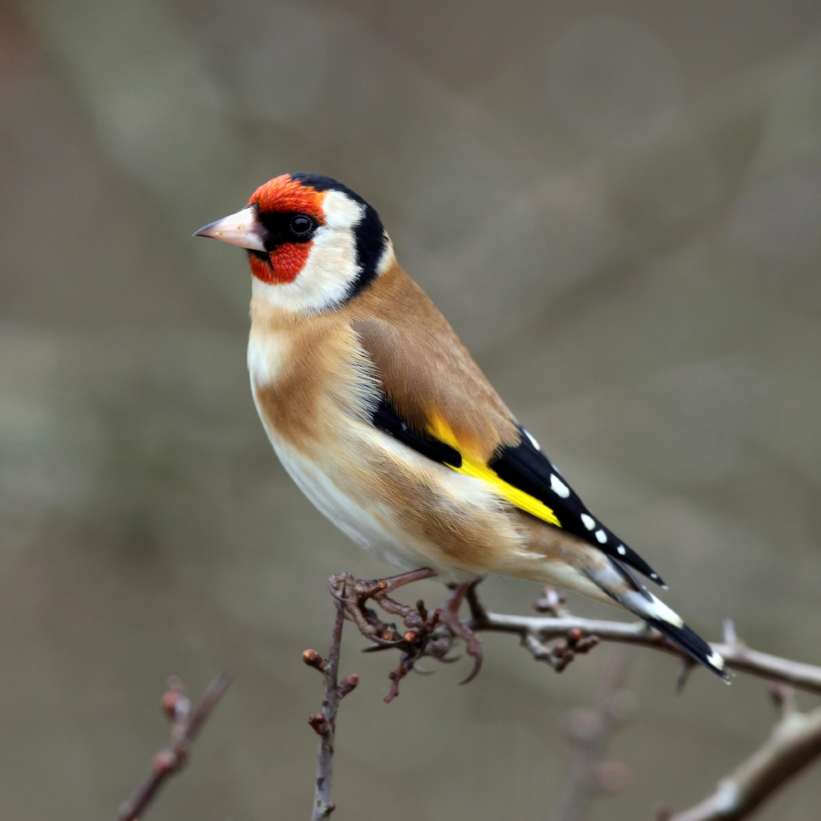

Welcome to the 9th of many newsletters from the world of birds. This will have fun facts and much more. We thank you for signing up to the newsletter and hope you are not disappointed by what you see here. Please email us if you have any inquires at theworldofbirdsoffical@gmail.com

24 for my top 25 most favourite birds is,

The Robin, to find out more pay a visit to our website http://theworldofbirds.weebly.com
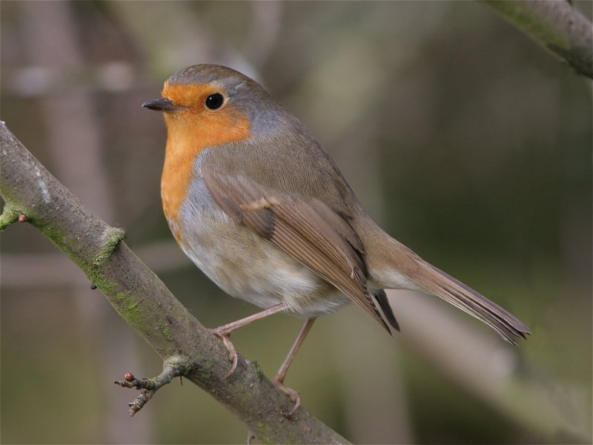
Birds seen this month!!!
- Coal tit Feral pigeons
- Ring-necked parakeet Magpie
- Jay Starling
- Black birds Gold crest
- Song thrush Black cap
- Great spotted woodpecker Green woodpecker
- Great tit Crow
- Dunnock Jackdaw
- Robin Collar dove
- Wren Nuthatch
- Chaffinch Sparrow hawk (male only)
- Goldfinch Siskin
- Greenfinch Pied wagtail
- Grey wagtail Long-tailed tit
- Tawny owl

Total: 29 species seen

Most seen bird of the month:
Blue Tit
Noisiest bird of the month:
Magpie

This issue is only sort as we are still waiting for our winter migrants to return. Next month’s issue will have the new winter migrant’s watch. We would love to join in with this too. Go to our website to find out more.

The Webcam should be up and running by the end of the Year sorry for any inconvenience!!!!

