iSSUE: 8

The World of birds

dATE: 23rd september 2014

Welcome
qUICK fACT
Did you know the fastest bird in the world is the Peregrine Falcon!!!

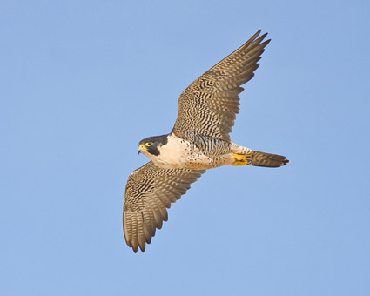

Welcome to the 8th of many newsletters from the world of birds. This will have fun facts and much more. We thank you for signing up to the newsletter and hope you are not disappointed by what you see here. Please email us if you have any inquires at theworldofbirdsoffical@gmail.com

21 for my top 25 most favourite birds is,

The Galah, to find out more pay a visit to our website http://theworldofbirds.weebly.com

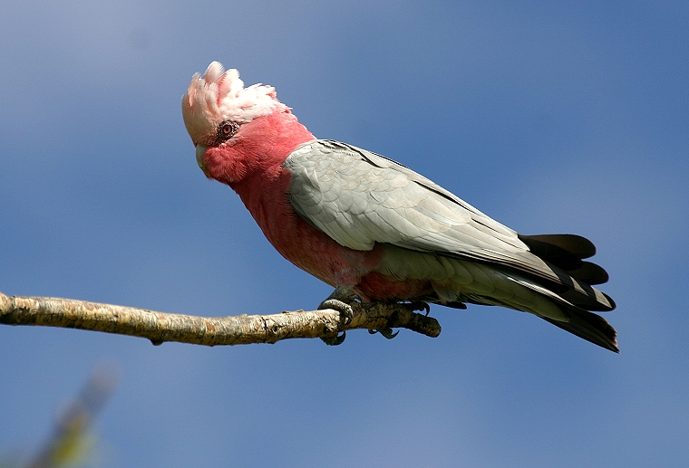
This is a Peregrine Falcon!!!
Fledgling count Update!!!
This year Garden Birds have started breeding late due to the mild winter and the birds becoming confused.
So far we have had between 40-50 Blue Tits, 12-18 Great Tits, 4-5 Robins, 3 Magpies, 2-4 Dunnocks, 5-10 Goldfinch, 3-5 Greenfinch, 1-2 Siskin, 6-15 Nuthatches, 25-30 Ring-Necked Parakeets, 3-5 Coal Tits, 3-5 Chaffinch, 1-3 Jay’s, 2 Great spotted Woodpeckers, 2 Green woodpecker, 5-6 Blackbirds, 10-12 House Martins, 5-6 Wood Pigeon’s, 2-3 Feral Pigeon’s, 5 Crows, 5-6 Long tailed tits
This is the final Fledgling count of this year!!!
Please note that the pigeons are still breeding at this time of year so there number could go up until the end of November.

Birds seen this month!!!
- Coal tit Feral pigeons
- Ring-necked parakeet Magpie
- Jay Starling
- Black birds Gold crest
- Song thrush Black cap
- Great spotted woodpecker Green woodpecker
- Great tit Crow
- Dunnock Jackdaw
- Robin Collar dove
- Wren Nuthatch
- Chaffinch Sparrow hawk (male only)
- Goldfinch Siskin
- Greenfinch Pied wagtail
- Grey wagtail Long-tailed tit
- Tawny owl

Total: 29 species seen

Most seen bird of the month:
Gold Finch
Noisiest bird of the month:
Tawny Owl

The Webcam should be up and running by the end of the Year sorry for any inconvenience!!!!

