iSSUE: 7

The World of birds

dATE: 10th August 2014

Welcome
qUICK fACT
Did you know that the ostrich is the largest bird in the world today!!!
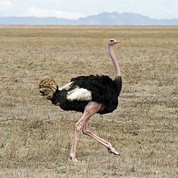

Welcome to the 7th of many newsletters from the world of birds. This will have fun facts and much more. We thank you for signing up to the newsletter and hope you are not disappointed by what you see here. Please email us if you have any inquires at theworldofbirdsoffical@gmail.com

21 for my top 25 most favourite birds is,

The Eurasian Jay, to find out more pay a visit to our website http://theworldofbirds.weebly.com

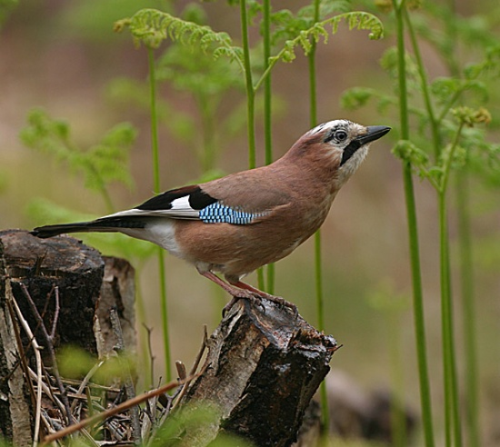
This is an Ostrich.
Fledgling count Update!!!
This year Garden Birds have started breeding late due to the mild winter and the birds becoming confused.
So far we have had between 40-60 Blue Tits, 12-20 Great Tits, 4-5 Robins, 3 Magpies, 2-4 Dunnocks, 3-5 Goldfinch, 3-5 Greenfinch, 1-2 Siskin, 6-15 Nuthatches, 25-30 Ring-Necked Parakeets, 3-5 Coal Tits, 3-5 Chaffinch, 1-3 Jay’s, 2 Great spotted Woodpeckers, 1 Green woodpecker, 4-6 Blackbirds, 10-15 House Martins, 4 Wood Pigeon’s, 2-4 Feral Pigeon’s, 2+ Crows, 2-6 Long tailed tits.
All the ones with + we think still have eggs. The others might as well, but these we are sure of. When we get the webcam set up we hope to show you our young birds. We also may have missed out birds in which case we will tell you next issue!!!

Birds seen this month!!!
- Coal tit Feral pigeons
- Ring-necked parakeet Magpie
- Jay Starling
- Black birds Gold crest
- Song thrush Black cap
- Great spotted woodpecker Green woodpecker
- Great tit Crow
- Dunnock Jackdaw
- Robin Collar dove
- Wren Nuthatch
- Chaffinch Sparrow hawk (male only)
- Goldfinch Siskin
- Greenfinch Pied wagtail
- Grey wagtail Long-tailed tit

Total: 28 species seen

Most seen bird of the month:
Blue Tit
Noisiest bird of the month:
Ring-Necked Parakeets

The Webcam should be up and running by the end of September sorry for any inconvenience!!!!

