iSSUE: 5

The World of birds

dATE: 22nd june 2014

Welcome
qUICK fACT
Did you know that the Goldfinch is now a wide spread garden bird throughout the UK. It has almost tripled the amount in the last 30 years. This is thought to be due to more people feeding the garden birds.

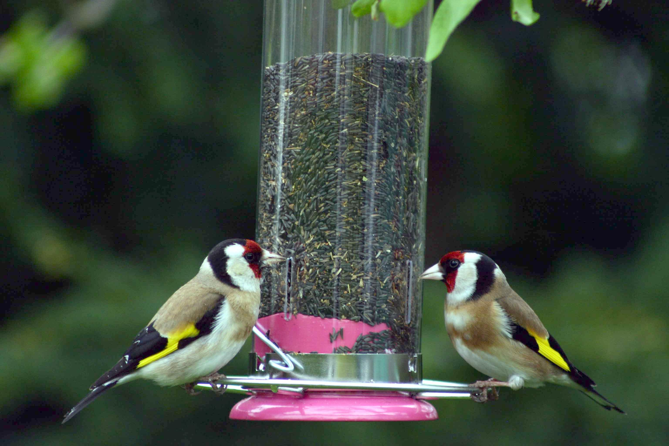

Welcome to the 5th of many newsletters from the world of birds. This will have fun facts and much more. We thank you for signing up to the newsletter and hope you are not disappointed by what you see here. Please email us if you have any inquires at theworldofbirdsoffical@gmail.com

20 for my top 20 most favourite birds is,

The Beared Tit, to find out more pay a visit to our website http://theworldofbirds.weebly.com

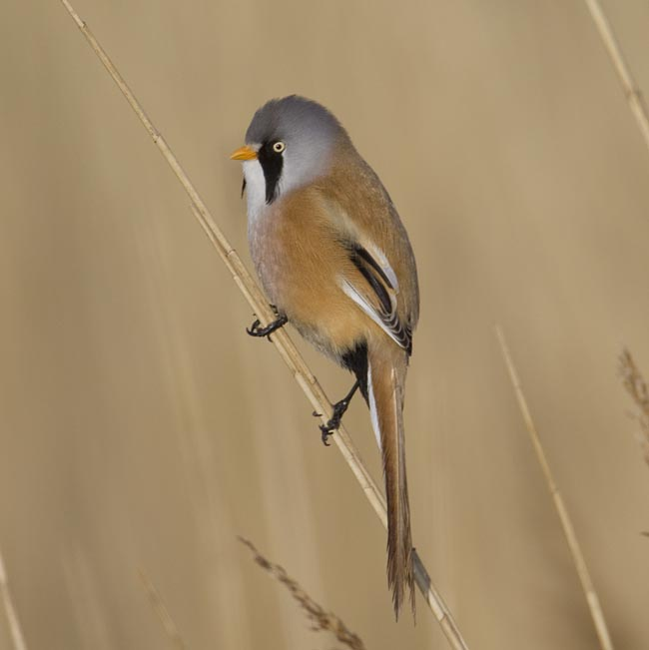
This is a Goldfinch.
Fledgling count!!!
This year Garden Birds have started breeding late due to the mild winter and the birds becoming confused.
So far we have had between 15-30 Blue Tits, 10-15 Great Tits, 3-5 Robins, 3 Magpies, 2+Dunnocks, 3+ Goldfinch, 3+ Greenfinch, 1+ Siskin, 5-15 Nuthatches, 10-15 Ring-Necked Parakeets, 2-4 Coal Tits, 3+Chaffinch, 1-3 Jay’s, 1-3 Great spotted Woodpeckers, 1+ Green woodpecker, 2-6 Blackbirds.
All the ones with + we think still have eggs. The others might as well, but these we are sure of. When we get the webcam set up we hope to show you our young birds. We also may have missed out birds in which case we will tell you next issue!!!

Birds seen this month!!!
- Coal tit Feral pigeons
- Ring-necked parakeet Magpie
- Jay Starling
- Black birds Gold crest
- Song thrush Black cap
- Great spotted woodpecker Green woodpecker
- Great tit Crow
- Dunnock Jackdaw
- Robin Collar dove
- Wren Nuthatch
- Chaffinch Sparrow hawk (male only)
- Goldfinch Siskin
- Greenfinch Pied wagtail
- Grey wagtail

Total: 27 species seen

Most seen bird of the month:
Magpie
Noisiest bird of the month:
Wren

Next issue we hope to bring you the best moments of our webcams!! Please note that the newsletter in July’s date may change please keep a close eye on the website!!

