iSSUE: 4

The World of birds

dATE: 21ST May 2014

Welcome
qUICK fACT
Did you know that there are 2 species of Parakeets living in the UK and both live in SouthEast England? There is the Ring-necked parakeet which lives in almost the whole of Southeast England especially North London, and there is the Monk Parakeet which only lives in Hertfordshire.

th

Welcome to the Fourth of many newsletters from the world of birds. This will have fun facts and much more. We thank you for signing up to the newsletter and hope you are not disappointed by what you see here. Please email us if you have any inquires at theworldofbirdsoffical@gmail.com

19 for my top 20 most favourite birds is,

The Blue Tit, to find out more pay a visit to our website http://theworldofbirds.weebly.com

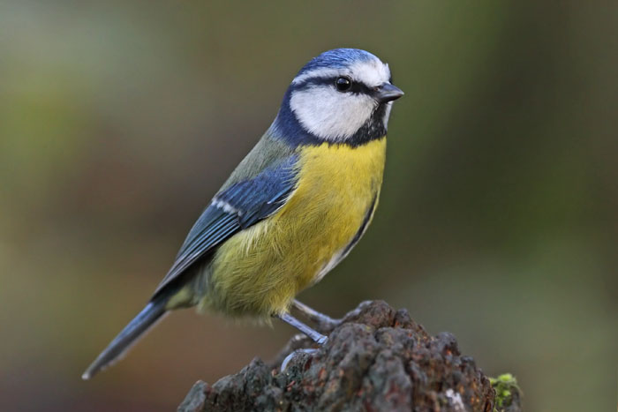
Feeding Garden Birds!!!
This year Garden Birds have started breeding late due to the mild winter and the birds becoming confused. We strongly encourage that anyone who normally takes there feeders down during the summer doesn’t take them down until at least the first week of July. We Have only just had our first Blue tit And Great tit nest out of at least 3 of each. This has so far produced 4+ Blue Tits and the Great Tits we haven’t managed to count yet, but there are at least 2.
Thank You
The World OF Birds Team
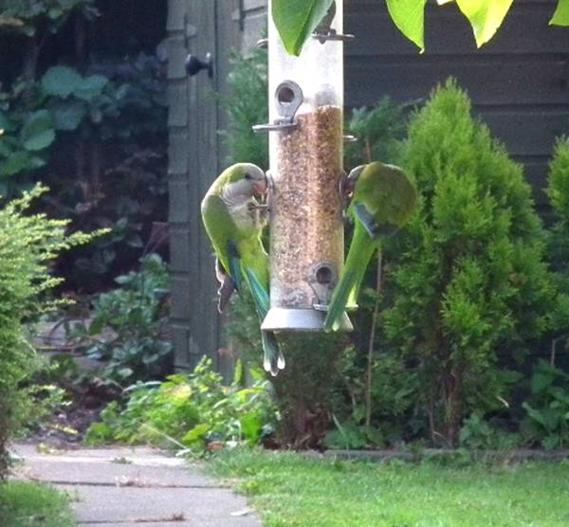
This is a Monk Parakeet

Birds seen this month!!!
- Coal tit Feral pigeons
- Ring-necked parakeet Magpie
- Jay Starling
- Black birds Gold crest
- Song thrush Black cap
- Great spotted woodpecker Green woodpecker
- Great tit Crow
- Dunnock Jackdaw
- Robin Collar dove
- Wren Nuthatch
- Chaffinch Sparrow hawk (male only)
- Goldfinch Siskin
- Greenfinch Pied wagtail
- Grey wagtail

Total: 27 species seen

Most seen bird of the month:
Blue Tit
Noisiest bird of the month:
Goldfinch

Next issue we hope to bring you the totals of our fledglings. Please note that the newsletter will come out on either Friday 20th of June or Sunday 22nd of June.

