iSSUE: 3

The World of birds

dATE: 21ST APRIL 2014

Welcome
qUICK fACT

Did you know that there are 2 subspecies of the Red Kite in the UK! One lives down the M40 corridor and one lives in wales. This is due to the locations they were introduced in!
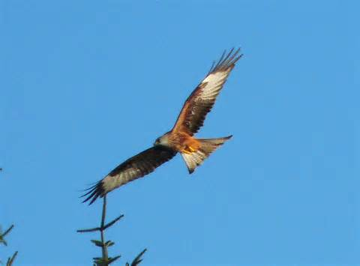

th

Welcome to the Third of many newsletters from the world of birds. This will have fun facts and much more. We thank you for signing up to the newsletter and hope you are not disappointed by what you see here. Please email us if you have any inquires at theworldofbirdsoffical@gmail.com

18 for my top 20 most favourite birds is,

The Hoopoe, to find out more pay a visit to our website http://theworldofbirds.weebly.com

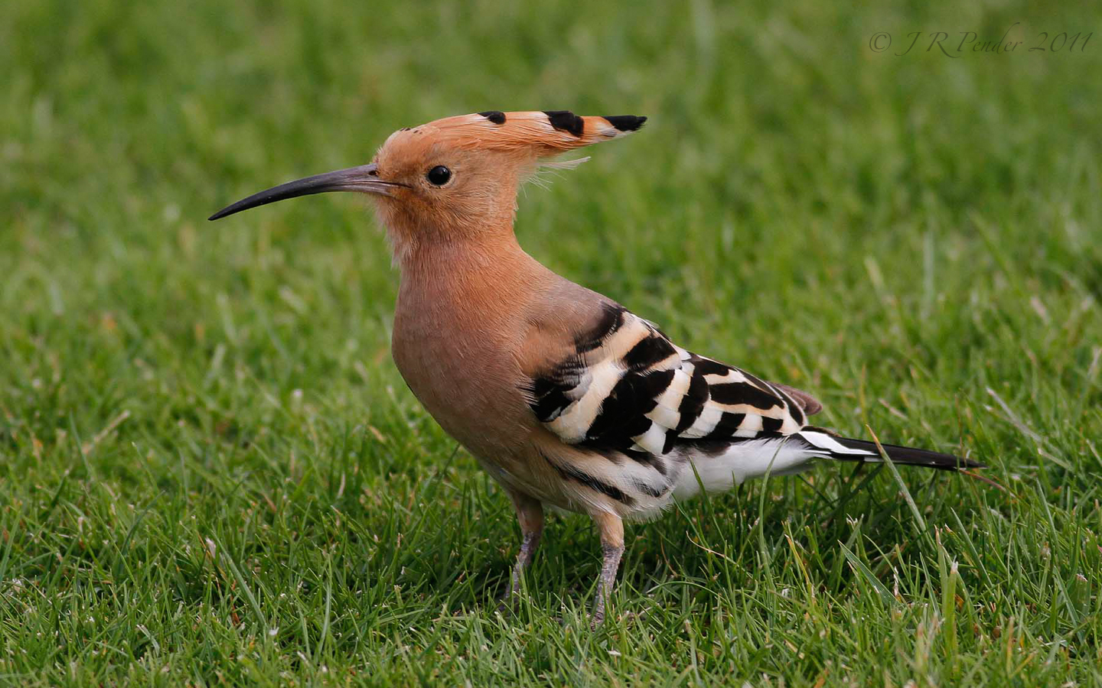
This is a Red Kite

Bird feeders we recommend to use!!!
We have had a lot of good feeders, but the best one we have had is certainly the Nuttery’s Globe Feeder. We highly recommend this as we have 3 which 2 of them have lasted for 4 years. We also recommend the Rspb’s Niger seed feeder with the cadge they do to go around it. The birds do take a while to get used to having the cadge around the feeder, but it does work. We also recommend the Nuttery’s fat ball and suet feeder as the squirrels can’t get into it and the birds don’t mind it. Here is what they look like below.

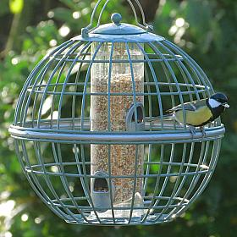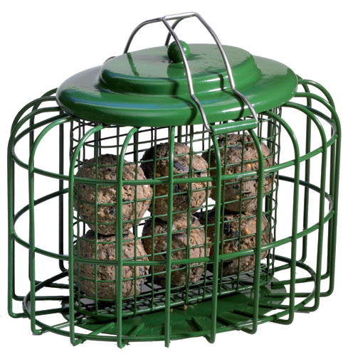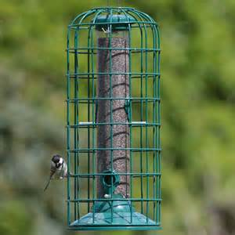
Birds seen this month!!!
- Coal tit Feral pigeons
- Ring-necked parakeet Magpie
- Jay Starling
- Black birds Gold crest
- Song thrush Black cap
- Great spotted woodpecker Green woodpecker
- Great tit Crow
- Dunnock Jackdaw
- Robin Collar dove
- Wren Nuthatch
- Chaffinch Sparrow hawk (male only)
- Goldfinch Siskin
- Greenfinch Pied wagtail
- Grey wagtail

Total: 27 species seen

Most seen bird of the month:
Blue Tit
Noisiest bird of the month:
Black Bird

We wish everybody a very happy Passover and Easter!!

