iSSUE: 26

The World of birds

dATE: 21st April 2016

Welcome
Did you know that, Even though they all have feathers, not all birds fly? There are 57 different species of flightless birds, including ostriches, emus, kiwis and all penguins. These birds may not take to the air, but they all have wings. When birds don't fly, their wings are used for different purposes, including courtship or threat displays, balance, steering or swimming.
This bird here is a Kiwi
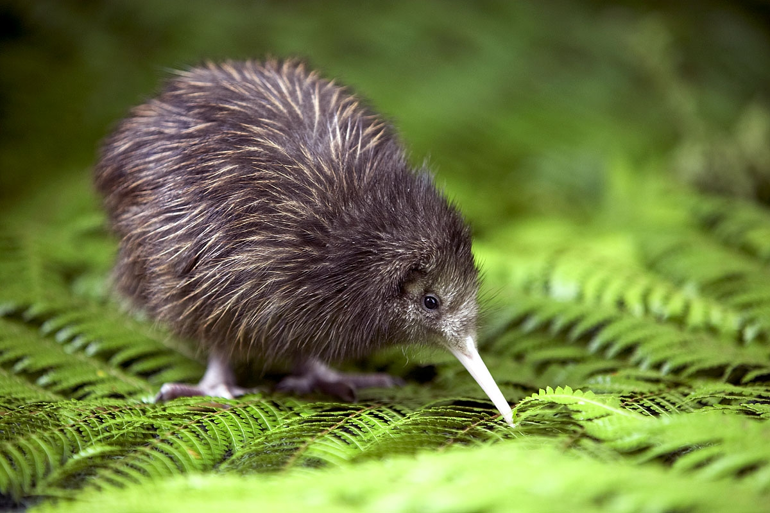

Did You know???
Welcome to the 26th of many newsletters from the world of birds. This will have fun facts and much more. We thank you for signing up to the newsletter and hope you are not disappointed by what you see here. Please email us if you have any inquires at theworldofbirdsoffical@gmail.com

42 for my top 50 most favourite birds is,

The Little Owl to find out more pay a visit to our website http://theworldofbirds.weebly.com
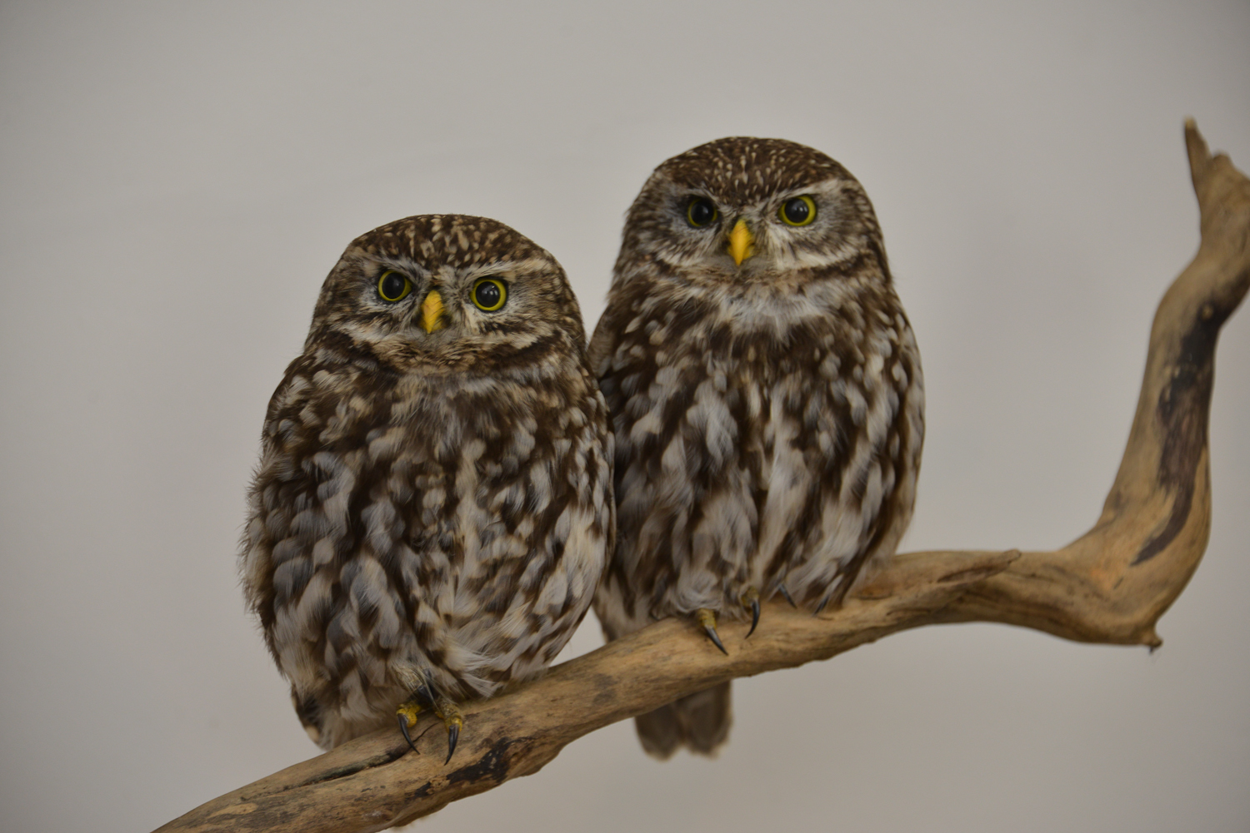
Birds seen this month!!!
- Coal tit Feral pigeons
- Ring-necked parakeet Magpie
- Jay Starling
- Black birds Gold crest
- Song thrush Black cap
- Great spotted woodpecker Green woodpecker
- Great tit Crow
- Dunnock Jackdaw
- Robin Collar dove
- Wren Nuthatch
- Chaffinch Sparrow hawk
- Goldfinch Siskin
- Greenfinch Pied wagtail
- Grey wagtail Long-tailed tit
- Tawny owl Stock Dove

Total: 30 species seen

Most seen bird of the month:
Goldfinch
Noisiest bird of the month:
Ring-necked parakeet

Our migrants UPDATE!!!
The Wood Pigeon winter roost has started to wind down however this year because the nights haven’t been particularly warm there are still 5-10 staying the night.
Also a record number of siskin was spotted on the second of October with a flock of 18-20. We still have at least 2 pairs (4 individuals) around whilst the others should have continued their journey onwards.
We also now have finally had a quick sighting of 2 male Blackcaps, and for the first time two female Black Caps that will hopefully stay and breed. There is still at least a pair that haven’t departed so fingers crossed.
We haven’t had any swifts or Swallows or House martins returning and with more northerly winds this weekend I wouldn’t blame them for not bothering yet.
We have also seen increased activity around the Blue Tits normal nesting area, however I am not sure that they will breed there this year!
Next Issue join us for more Winter Migrant watch and the beginning of Summer Migrant watch and Fledgling Count!
There will be no May issue!!!
This means that the next issue will be out around the 21st June 2016!
We would love you to join in with our Winter Migrant Watch. Go to our website to find out more. http://theworldofbirds.weebly.com

