iSSUE: 25

The World of birds

dATE: 21st March 2016

Welcome
Did you know that, there are approximately 10,000 bird species today, more than all mammals and amphibians combined, and new bird species are discovered almost every year? Some of these species are brand new discoveries of unique birds in isolated, poorly explored habitats. Other new species, however, are former subspecies that are split from a larger species after detailed research determines the birds are actually a distinct species. Much of that research is through DNA analysis or other sophisticated means.

Did You know???
Welcome to the 25th of many newsletters from the world of birds. This will have fun facts and much more. We thank you for signing up to the newsletter and hope you are not disappointed by what you see here. Please email us if you have any inquires at theworldofbirdsoffical@gmail.com

41 for my top 40 most favourite birds is,

The Grey Wagtail to find out more pay a visit to our website http://theworldofbirds.weebly.com
Birds seen this month!!!
- Coal tit Feral pigeons
- Ring-necked parakeet Magpie
- Jay Starling
- Black birds Gold crest
- Song thrush Black cap
- Great spotted woodpecker Green woodpecker
- Great tit Crow
- Dunnock Jackdaw
- Robin Collar dove
- Wren Nuthatch
- Chaffinch Sparrow hawk
- Goldfinch Siskin
- Greenfinch Pied wagtail
- Grey wagtail Long-tailed tit
- Tawny owl Stock Dove

Total: 30 species seen

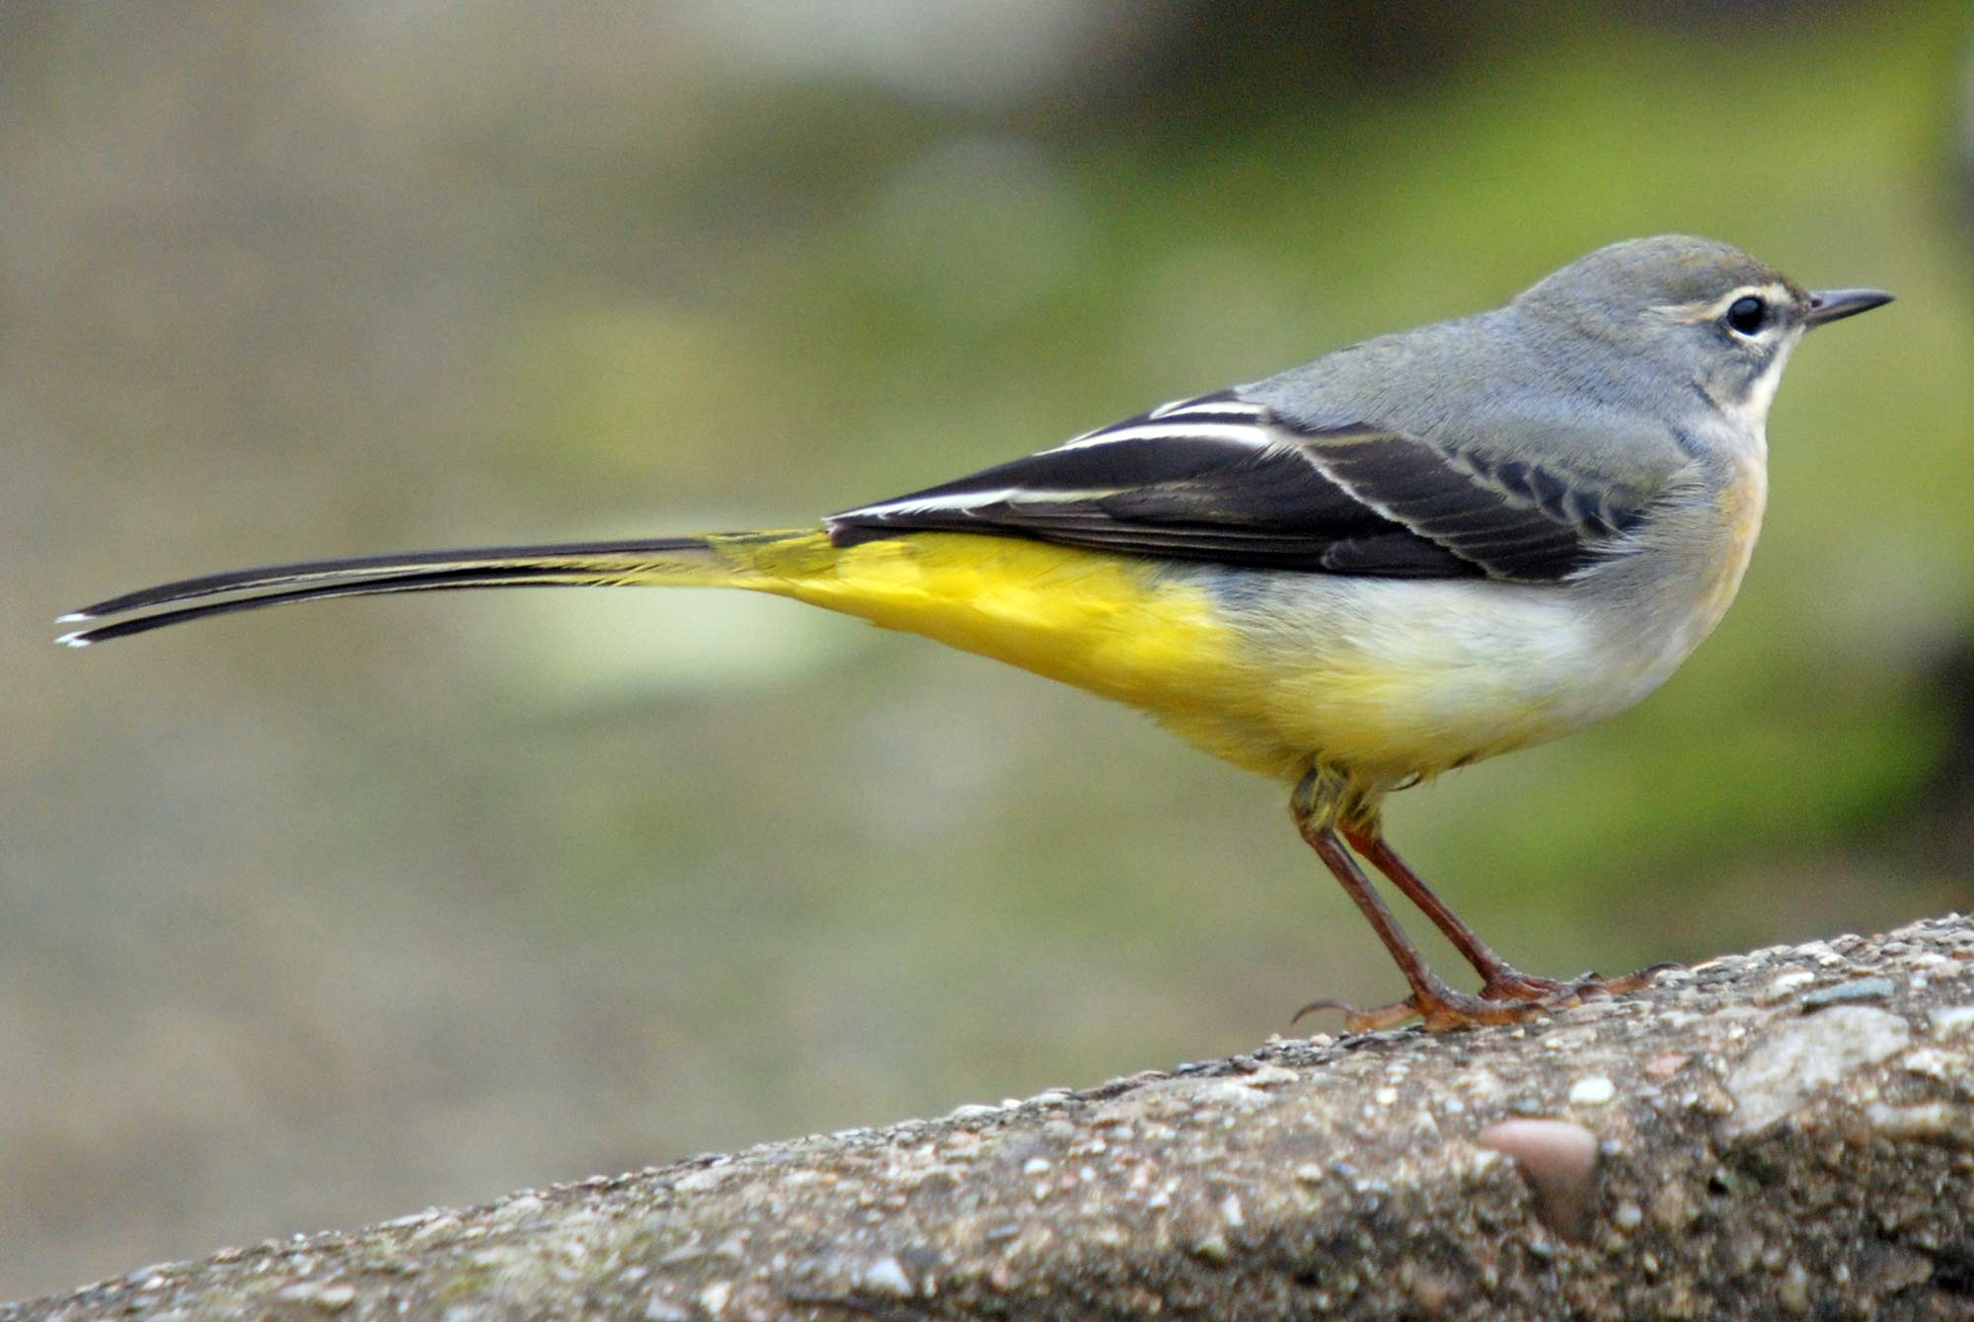

Most seen bird of the month:
Siskin
Noisiest bird of the month:
Coal Tit

Our migrants UPDATE!!!
The Wood Pigeon winter roost has started to wind down with only about 20-30 roosting every night, however day time numbers are rocketing.
Also a record number of siskin was spotted on the second of October with a flock of 18-20.
We also now have finally had a quick sighting of 2 male Blackcaps, and for the first time two female Black Caps that will hopefully stay and breed.
These last two months have been truly amazing with bumper flocks for all species. Now it is at its peak as nest material is busily being carried away and the birds are getting the last bits of energy before they have to nest/ migrate. We hope this amount of activity will last for a long time, but as the days get warmer and longer we know that the breeding season is around the corner.
Next Issue join us for more Winter Migrant watch and the beginning of Summer Migrant watch!
The next issue will be out around 21st April!!!
We would love you to join in with our Winter Migrant Watch. Go to our website to find out more. http://theworldofbirds.weebly.com

