iSSUE: 24

The World of birds

dATE: 21st January 2016

Welcome

Did you know that Atlantic puffins can beat their wings over 400 times a minute allowing them to reach speeds of 55mph?

This Is An Atlantic Puffin!
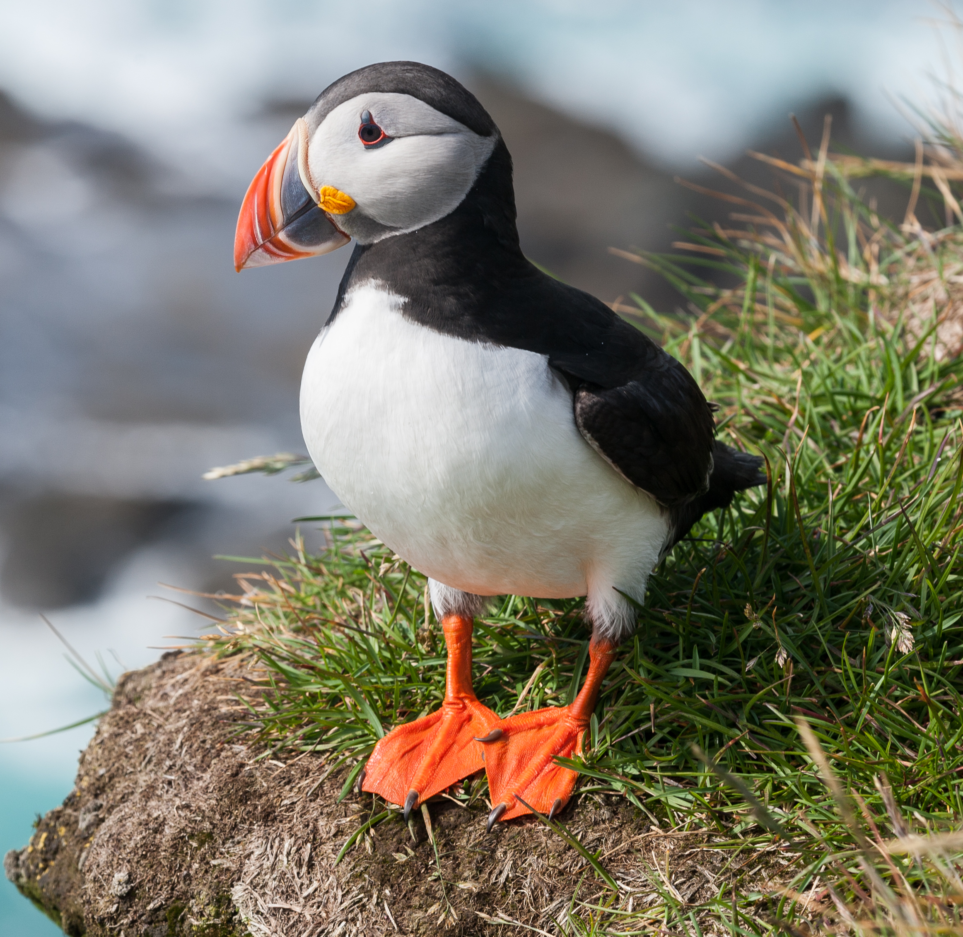
Did You know???
Welcome to the 24th of many newsletters from the world of birds. This will have fun facts and much more. We thank you for signing up to the newsletter and hope you are not disappointed by what you see here. Please email us if you have any inquires at theworldofbirdsoffical@gmail.com

39 for my top 40 most favourite birds is,

The Red-vented Bulbul to find out more pay a visit to our website http://theworldofbirds.weebly.com
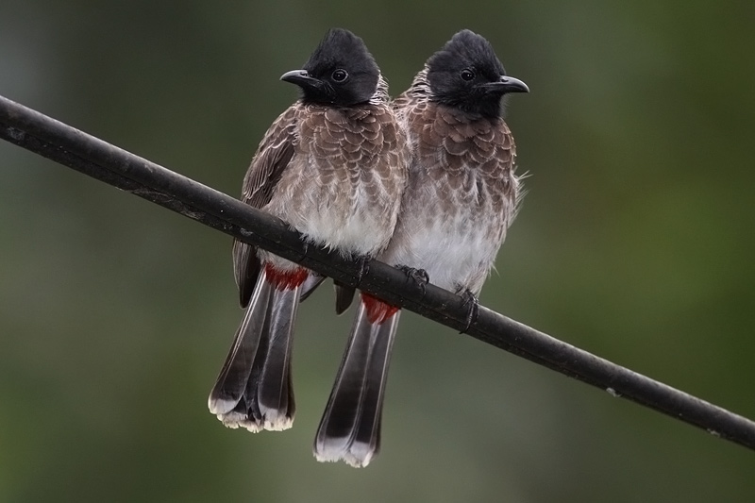
Birds seen this month!!!
- Coal tit Feral pigeons
- Ring-necked parakeet Magpie
- Jay Starling
- Black birds Gold crest
- Song thrush Black cap
- Great spotted woodpecker Green woodpecker
- Great tit Crow
- Dunnock Jackdaw
- Robin Collar dove
- Wren Nuthatch
- Chaffinch Sparrow hawk (male only)
- Goldfinch Siskin
- Greenfinch Pied wagtail
- Grey wagtail Long-tailed tit
- Tawny owl Stock Dove

Total: 30 species seen

Most seen bird of the month:
Goldfinch
Noisiest bird of the month:
Tawny Owl

Our migrants UPDATE!!!
Every morning we are treated by the Redwing between 7-8am a mass departure, and then they return to feed on the grass between 3:50-4:30pm and then to roost. There is likely to be more than 31 now however as they are always on the move it is almost impossible to count.
We have also seen increased amounts of Wood Pigeons turning up to the normal winter roost. At the moment there are about 100, more could turn up.
Our goldfinches are back and with a bang with a flock of nearly 20. Also a record number of siskin was spotted on the second of October with a flock of 8 or 9. They haven’t been seen since. Our flock of Magpies has returned too, but with only 11 instead of 18. We now also have our flock of Chaffinch back with around 10 individuals at the moment. We also now have finally had a quick sighting of 2 male Blackcaps, however they haven’t been seen since they were first spotted on the 11th of January.
In other news we had a pair of Ring Necked parakeets busily feeding young from an old Woodpecker hole. This is unusual for this time of year and maybe one of, if not the first record this late in the year. We have some bad news and it appears that due to the recent cold snap only one of the young parakeets managed to survive and this particular one appears to have no tail. This means that there may have actually been an intruder to the nest as well as the cold weather.

Next Issue join us for more Winter Migrant watch!
The next issue will be out around 21st February!!!
We would love you to join in with our Winter Migrant Watch. Go to our website to find out more. http://theworldofbirds.weebly.com

