iSSUE: 23

The World of birds

dATE: 21st december 2015

Welcome
Did you know that due to the exceptionally mild weather this winter passage migrants such as the Hoopoe have decided to winter here instead of Northern Africa? Also Swifts and Swallows have been spotted on the south coast too.
This is a Hoopoe!
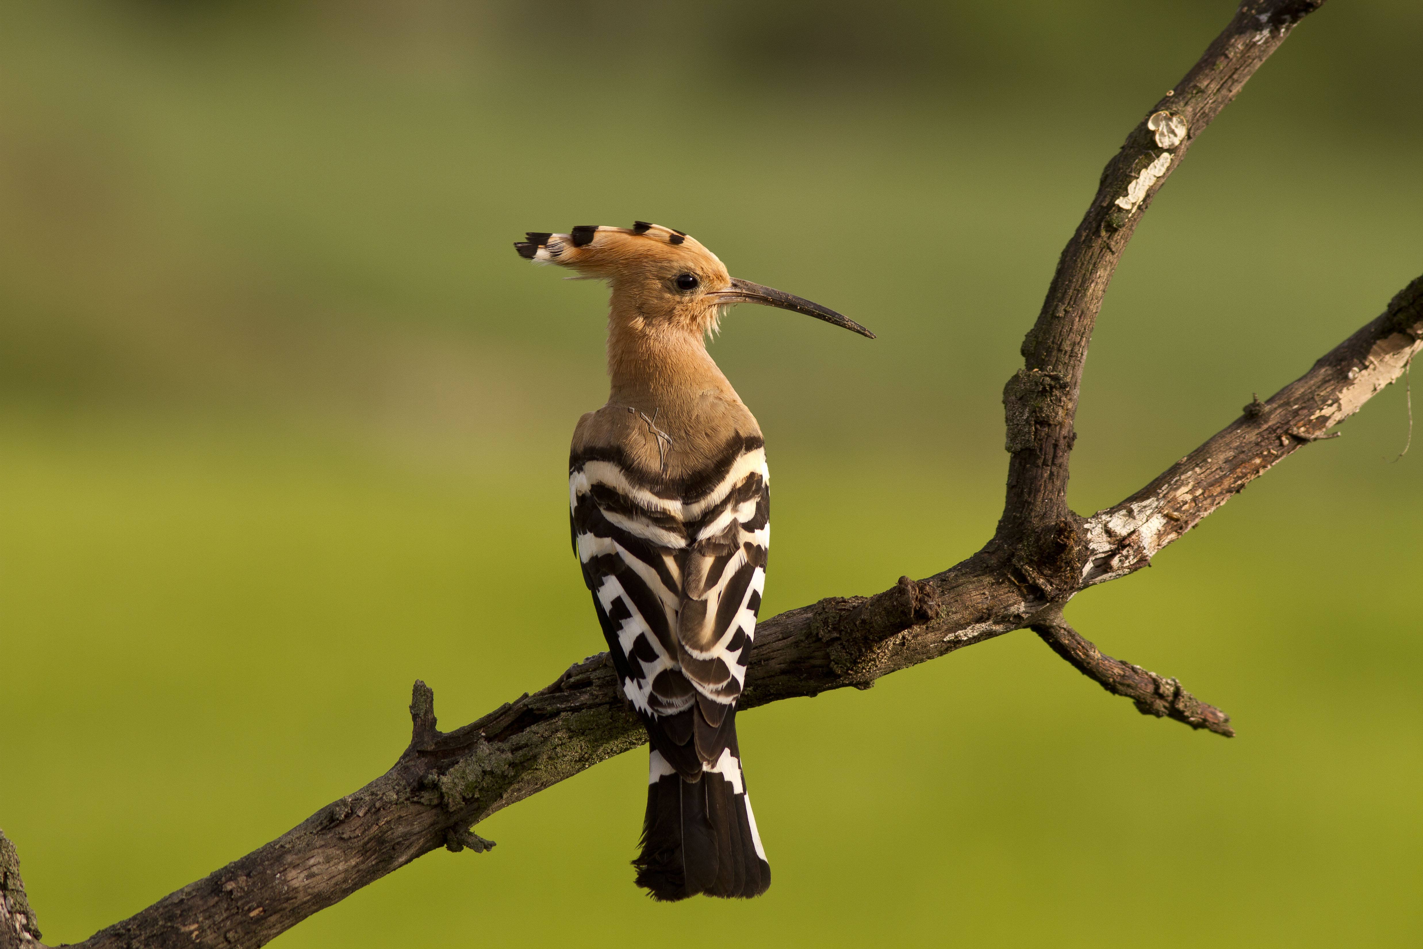
Did You know???
Welcome to the 23rd of many newsletters from the world of birds. This will have fun facts and much more. We thank you for signing up to the newsletter and hope you are not disappointed by what you see here. Please email us if you have any inquires at theworldofbirdsoffical@gmail.com

38 for my top 40 most favourite birds is,

The Oriental Magpie Robin to find out more pay a visit to our website http://theworldofbirds.weebly.com
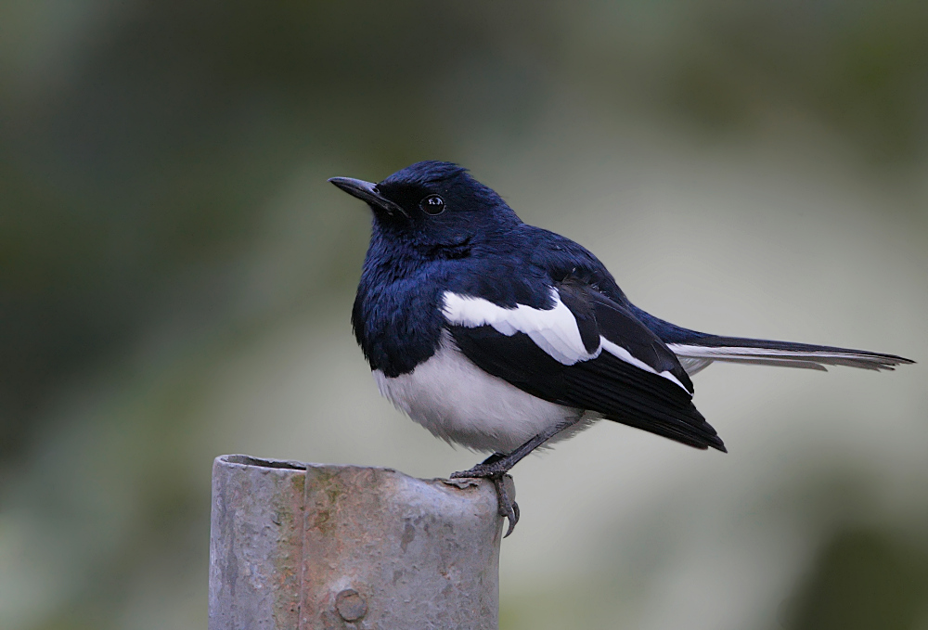
Birds seen this month!!!
- Coal tit Feral pigeons
- Ring-necked parakeet Magpie
- Jay Starling
- Black birds Gold crest
- Song thrush Black cap
- Great spotted woodpecker Green woodpecker
- Great tit Crow
- Dunnock Jackdaw
- Robin Collar dove
- Wren Nuthatch
- Chaffinch Sparrow hawk (male only)
- Goldfinch Siskin
- Greenfinch Pied wagtail
- Grey wagtail Long-tailed tit
- Tawny owl Stock Dove

Total: 30 species seen

Most seen bird of the month:
Redwing
Noisiest bird of the month:
Blackbird

Our migrants UPDATE!!!
Winter Chiffchaffs have started to arrive and can already be seen and heard at the moment, The Black caps and Redwings are still waiting for those strong easterly winds as they have missed their first opportunity!
On Sunday 7th of November after a two year absence a flock of 31 Red Wing gave us our normal winter fly by after only 1 turning up last year. We are now getting regular visits as they have set up roost in our area. We are treated every morning between 7-8am a mass departure, and then they return to feed on the grass between 3:30-4pm and then to roost.
We have also seen increased amounts of Wood Pigeons turning up to the normal winter roost. At the moment there are about 50, however we expect between 100-200 more. Our goldfinches our also returning with a flock of 6 at the moment at the roost. We expect between 5-10 more to turn up. Also a record number of siskin was spotted on the second of October with a flock of 8 or 9. They haven’t been seen since. Our flock of Magpies has returned too, but with only 11 instead of 18.
We have also had the return of at least 3 Stock Dove, 3 Collared Doves, and 3 Greenfinch!
In other news we have a pair of Ring Necked parakeets busily feeding young from an old Woodpecker hole. This is unusual for this time of year and maybe one of, if not the first record this late in the year. The young look as though they will leave the nest in the coming days if the weather holds.

Next Issue join us for more Winter Migrant watch!
The next issue will be out around 21st January!!!
We would love you to join in with our Winter Migrant Watch. Go to our website to find out more. http://theworldofbirds.weebly.com
The Webcam should be up and running by the end of the spring (April/May) 2016 Sorry for any inconvenience!!!!

