iSSUE: 22

The World of birds

dATE: 21st november 2015

Welcome
qUiCK fACT

Did you know that in winter the Red Winged Black Bird will form gender specific flocks?
This is a flock of Red Winged Black Birds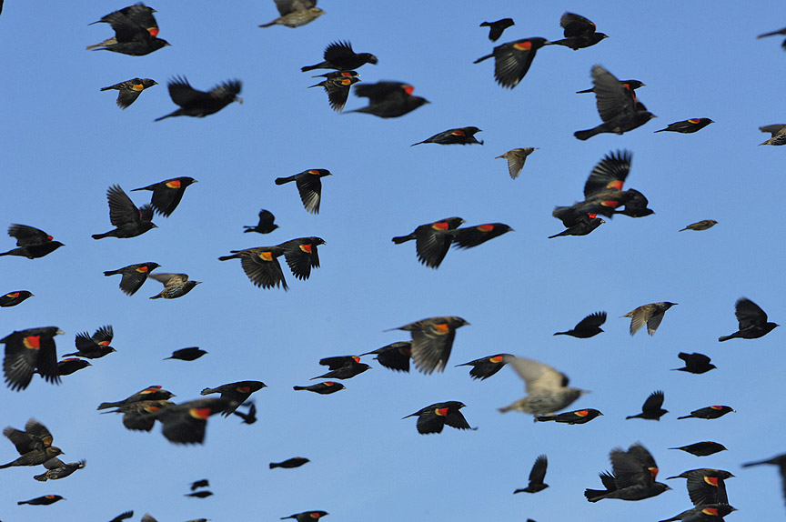

Welcome to the 22nd of many newsletters from the world of birds. This will have fun facts and much more. We thank you for signing up to the newsletter and hope you are not disappointed by what you see here. Please email us if you have any inquires at theworldofbirdsoffical@gmail.com

37 for my top 40 most favourite birds is,

The Red Winged Blackbird to find out more pay a visit to our website http://theworldofbirds.weebly.com
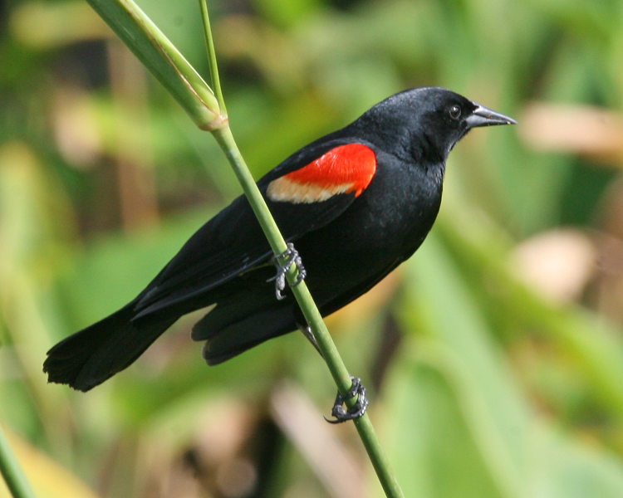
Birds seen this month!!!
- Coal tit Feral pigeons
- Ring-necked parakeet Magpie
- Jay Starling
- Black birds Gold crest
- Song thrush Black cap
- Great spotted woodpecker Green woodpecker
- Great tit Crow
- Dunnock Jackdaw
- Robin Collar dove
- Wren Nuthatch
- Chaffinch Sparrow hawk (male only)
- Goldfinch Siskin
- Greenfinch Pied wagtail
- Grey wagtail Long-tailed tit
- Tawny owl Stock Dove

Total: 30 species seen

Most seen bird of the month:
Long-tailed Tit
Noisiest bird of the month:
Goldfinch

Our migrants UPDATE!!!
Winter Chiffchaffs have started to arrive and can already be seen and heard at the moment, The Black caps and Redwings are still waiting for those strong easterly winds as they have missed their first opportunity!
On Sunday 7th of November after a two year absence a flock of 31 Red Wing gave us our normal winter fly by after only 1 turning up last year. However they haven’t been seen since.
We have also seen increased amounts of Wood Pigeons turning up to the normal winter roost. At the moment there are about 50, however we expect between 100-200 more. Our goldfinches our also returning with a flock of 6 at the moment at the roost. We expect between 5-10 more to turn up. Also a record number of siskin was spotted on the second of October with a flock of 8 or 9. They haven’t been seen since.
Next Issue join us for more Winter Migrant watch!
Also in mammal news on the 11th of November in broad day light we saw the first bat recorded at this site. We think that this was a Common Pipistrelle Bat. We hope that the bat returns and hopefully with friends.
The next issue will be out around 21st December!!!
We would love you to join in with our Winter Migrant Watch. Go to our website to find out more. http://theworldofbirds.weebly.com
The Webcam should be up and running by the end of the spring (April/May) 2016 Sorry for any inconvenience!!!!

