iSSUE: 21

The World of birds

dATE: 21st October 2015

Welcome
qUiCK fACT

Did you know that a group of larks is called an exaltation, a group of chickens is called a peep, a group of geese is called a gaggle, a group of ravens is called a murder, and a group of owls is called a parliament?
This is an Murder of Ravens!!!
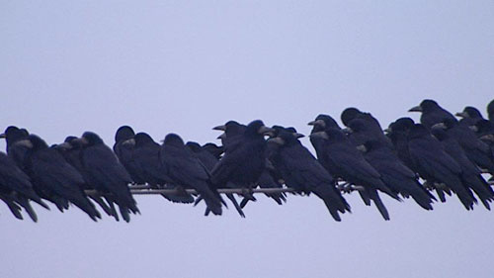

Welcome to the 21st of many newsletters from the world of birds. This will have fun facts and much more. We thank you for signing up to the newsletter and hope you are not disappointed by what you see here. Please email us if you have any inquires at theworldofbirdsoffical@gmail.com

35 for my top 35 most favourite birds is,

The Northern Pintail Duck to find out more pay a visit to our website http://theworldofbirds.weebly.com
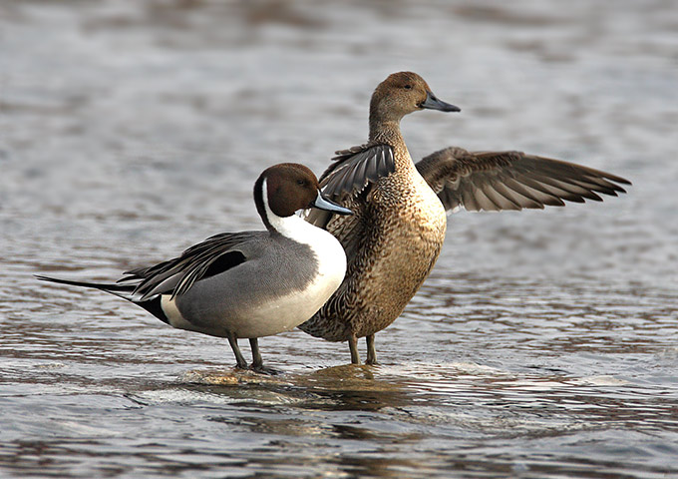
Most seen bird of the month:
Ring-necked Parakeet
Noisiest bird of the month:
Robin
Birds seen this month!!!
- Coal tit Feral pigeons
- Ring-necked parakeet Magpie
- Jay Starling
- Black birds Gold crest
- Song thrush Black cap
- Great spotted woodpecker Green woodpecker
- Great tit Crow
- Dunnock Jackdaw
- Robin Collar dove
- Wren Nuthatch
- Chaffinch Sparrow hawk (male only)
- Goldfinch Siskin
- Greenfinch Pied wagtail
- Grey wagtail Long-tailed tit
- Tawny owl Stock Dove

Total: 30 species seen

Our migrants UPDATE!!!
Winter Chiffchaffs have started to arrive and can already be seen and heard at the moment, The Black caps and Redwings are still waiting for those strong easterly winds as they have missed their first opportunity!
Next Issue join us for: Winter Migrant watch and possibly The Final fledgling count.

Fledgling Report
Species | Number | Comment
Blue tit | 40+ | This is our record year doubling last year’s count.
Great tit | 30+ | This is yet again a record year doubling last year’s count.  I regretfully inform you that at least 1 has been taken by the sparrow hawk.
Coal Tit | 6 | This is 2 above the average
Long-tailed Tit | 40+ | This is a record amount tripling our annual count.
Ring-necked Parakeets | 15+ | This is a record year as we normally only get 7 individuals at any one time.
Great Spotted Woodpecker | 2 | This is the same amount our pair has produced for the last 6 years. They are now attempting to raise a second brood!!!
Robin | 6 | This is about average!
Wren | 6+ | Our record year as we have only ever had as many as 5 before.
Magpie | 4 | This is below average as we have had 6+ for the last 6 years.
Starling | 20 | This is the first year we have had starling and 4 adults managed to fledge 20 young.
Jackdaw | 20+ | This is the first year we have had more than one pair breed.
Crow | 4 | This is below average, but we are not too hopeful of getting more!
Jay | 2 | This is average
Black Bird | 6 | This is about average
Wood Pigeon | 25 | This is still expected to increase slowly in the coming months
Feral Pigeon | 4 | This is the first year that we have recorded young from them in the garden and we could have more soon.
Goldfinches | 4 | This the first time we have had more than one survive the first week! I regretfully inform you that at least 2 have been taken by the sparrow hawk.
Gold Crests | 4 | This is the double the normal count.
Green Woodpecker | 2 | This is normal
Greenfinches | 6 | They may have been late, however better late than never. This is the most we have had. They have in the past averaged at 2 or 3. I regretfully inform you that at least 2 have been taken by the sparrow hawk.
Chaffinches | 2 | This is below average and we may have the sparrow hawk to blame for this!!!
Nuthatches | 2-3? | We haven’t had a glimpse of the young yet so we don’t know how many there are yet. They have however fledged.  We still don’t know how many there are as they have dispersed and left us with only the two parents.

Join us next issue to find out how many more fledglings have appeared.
The next issue will be out around 21st November!!!
We would love you to join in with our Summer Migrant Watch. Go to our website to find out more. http://theworldofbirds.weebly.com
The Webcam should be up and running by the end of the winter (January/February) 2016 Sorry for any inconvenience!!!!

