iSSUE: 2

The World of birds

dATE: 21ST January 2014

Welcome
qUICK fACT

The Ring-necked Parakeet is the only parakeet to live in England. There are now nearing 100,000 in the UK!! (mainly in the south east of England)
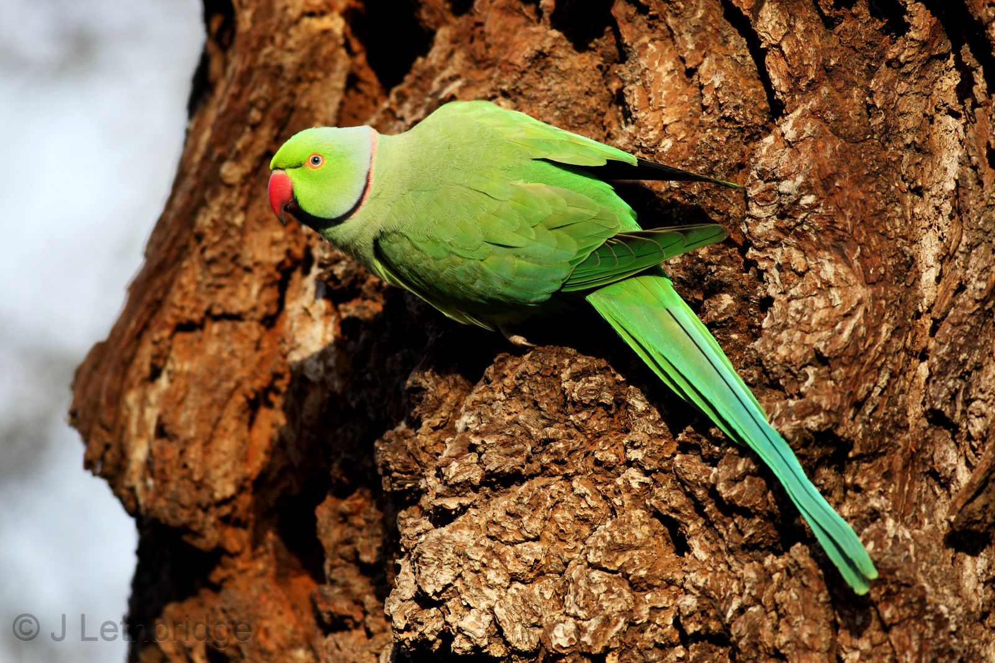

th

Welcome to the Second of many newsletters from the world of birds. This will have fun facts and much more. We thank you for signing up to the newsletter and hope you are not disappointed by what you see here. Please email us if you have any inquires at theworldofbirdsoffical@gmail.com

14 for my top 15 most favourite birds is,

The Redwing, to find out more pay a visit to our website http://theworldofbirds.weebly.com

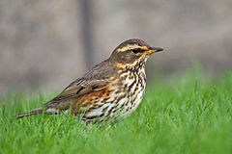
This is a Ring-Necked Parakeet

Bird feeders we recommend not to use!!!!
We have had problems with the nuttery’s extra-large squirrel prof feeders as the squirrel’s just take the lids off and get in that way. We have also had problems with the squirrel buster as this gets stuck and so the food is enclosed from the birds. Join us next issue when we recommend lots of feeders!!! Below the whole of the extra-large range and the Squirrel buster.
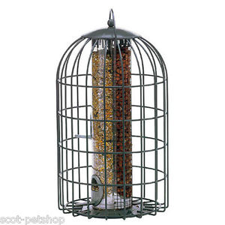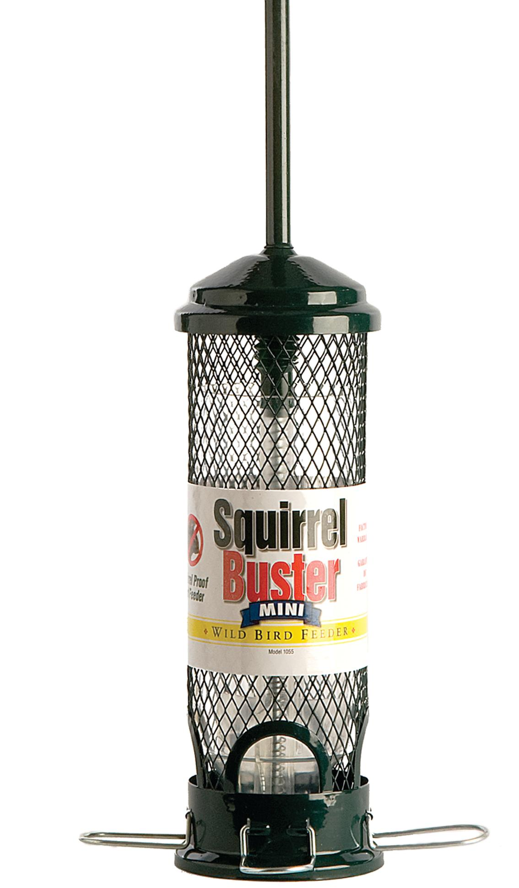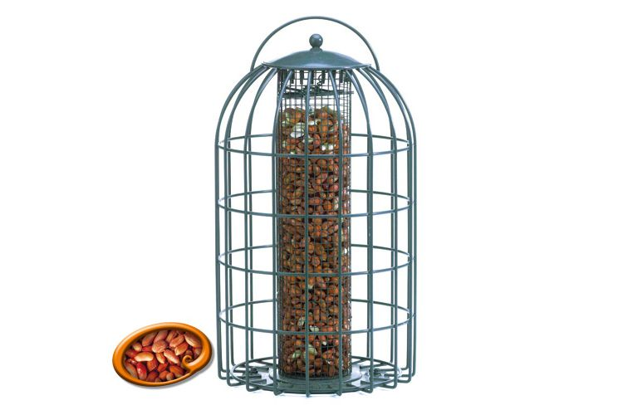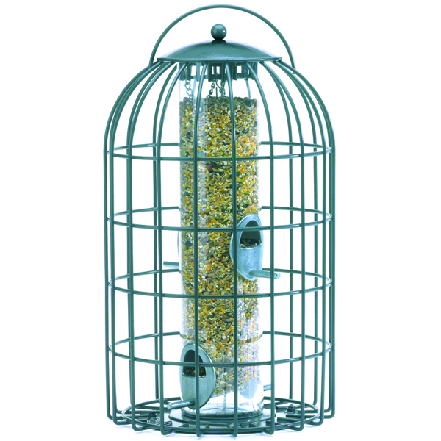
Birds seen this month!!!
- Coal tit Feral pigeons
- Blue tit Wood pigeons
- Ring-necked parakeet Magpie
- Jay Starling
- Black birds Gold crest
- Song thrush Black cap
- Great spotted woodpecker Green woodpecker
- Great tit Crow
- Dunnock Jackdaw
- Robin Collar dove
- Wren Nuthatch
- Chaffinch Sparrow hawk (male only)
- Goldfinch Redwing
- Greenfinch Green woodpecker
- Grey wagtail Pied wagtail

Total: 30 species seen

Most seen bird of the month:
Gold Finch
Noisiest bird of the month:
Magpie

