iSSUE: 19

The World of birds

dATE: 26th August 2015

Welcome
qUiCK fACT

Did you know that the most common bird in the UK is the Wren?There are thought to be around 8.5million breeding territories in the UK. This may surprise some people because they aren’t as regularly seen as woodpigeons or House Sparrows for example.
This is a Wren. 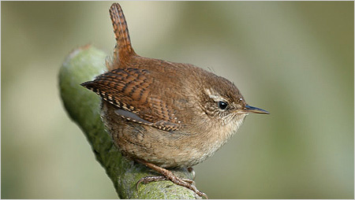

Welcome to the 19th of many newsletters from the world of birds. This will have fun facts and much more. We thank you for signing up to the newsletter and hope you are not disappointed by what you see here. Please email us if you have any inquires at theworldofbirdsoffical@gmail.com

34 for my top 35 most favourite birds is,

The Mandarin Duck, to find out more pay a visit to our website http://theworldofbirds.weebly.com
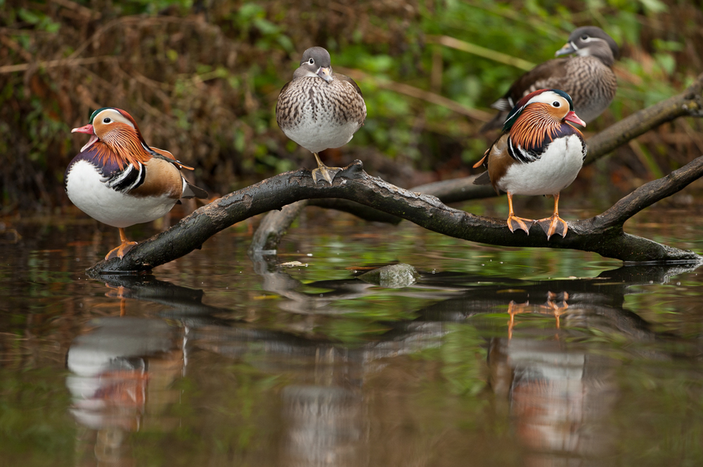
Most seen bird of the month:
Goldfinch
Noisiest bird of the month:
Ring-necked Parakeets

Birds seen this month!!!
- Coal tit Feral pigeons
- Ring-necked parakeet Magpie
- Jay Starling
- Black birds Gold crest
- Song thrush Black cap
- Great spotted woodpecker Green woodpecker
- Great tit Crow
- Dunnock Jackdaw
- Robin Collar dove
- Wren Nuthatch
- Chaffinch Sparrow hawk (male only)
- Goldfinch Siskin
- Greenfinch Pied wagtail
- Grey wagtail Long-tailed tit
- Tawny owl Stock Dove

Total: 30 species seen

Our migrants UPDATE!!!
Our summer migrants have left early this year due to the poor weather. This could prompt and early start to the winter migration!
Next Issue Join us For Summer migrant watch, Winter migrant and Fledgling count.
Fledgling Report
Species | Number | Comment
Blue tit | 40+ | This is our record year doubling last year’s count.
Great tit | 30+ | This is yet again a record year doubling last year’s count.
Coal Tit | 4+
Long-tailed Tit | 40+ | This is a record amount tripling our annual count.
Ring-necked Parakeets | 15+ | This is a record year as we normally only get 7 individuals at any one time.
Great Spotted Woodpecker | 2 | This is the same amount our pair has produced for the last 6 years.
Robin | 4 | We are expecting more.
Wren | 6+ | Our record year as we have only ever had as many as 5 before.
Magpie | 4 | This is below average as we have had 6+ for the last 6 years.
Starling | 20 | This is the first year we have had starling and 4 adults managed to fledge 20 young.
Jackdaw | 20+ | This is the first year we have had more than one pair breed.
Crow | 4 | This is below average, but we are not too hopeful of getting more!
Jay | 2 | This is average
Black Bird | 6 | This is about average
Wood Pigeon | 8 | This expected to double in the coming months
Feral Pigeon | 2 | This is the first year that we have recorded young from them in the garden and we should have more soon.
Goldfinches | 3 | This the first time we have had more than one survive the first week!
Gold Crests | 4 | This is the double the normal count.
Green Woodpecker | 2 | This is normal
Chaffinches and Greenfinches | 0 | They are behind schedule so should appear by the middle of september.
Nuthatches | 0 | They are so very close to fledging and probably will as soon as the weather gets better!

Join us next issue to find out how many more fledglings have appeared.
The next issue will be out around 21st September!!!
We would love you to join in with our Summer Migrant Watch. Go to our website to find out more. http://theworldofbirds.weebly.com
The Webcam should be up and running by the end of the winter (January/February) 2016 Sorry for any inconvenience!!!!

