iSSUE: 17

The World of birds

dATE: 30th june 2015

Welcome
qUiCK fACT

Did you know that only 20% of the birds in the world Migrate???
This is a Hobby

Welcome to the 17th of many newsletters from the world of birds. This will have fun facts and much more. We thank you for signing up to the newsletter and hope you are not disappointed by what you see here. Please email us if you have any inquires at theworldofbirdsoffical@gmail.com

32 for my top 35 most favourite birds is,

The Barn Swallow, to find out more pay a visit to our website http://theworldofbirds.weebly.com
Birds seen this month!!!
- Coal tit Feral pigeons
- Ring-necked parakeet Magpie
- Jay Starling
- Black birds Gold crest
- Song thrush Black cap
- Great spotted woodpecker Green woodpecker
- Great tit Crow
- Dunnock Jackdaw
- Robin Collar dove
- Wren Nuthatch
- Chaffinch Sparrow hawk (male only)
- Goldfinch Siskin
- Greenfinch Pied wagtail
- Grey wagtail Long-tailed tit
- Tawny owl Stock Dove

Total: 30 species seen

Most seen bird of the month:
Blue Tit
Noisiest bird of the month:
Ring-necked Parakeets

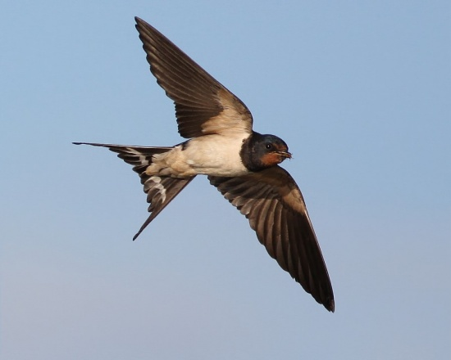

Our migrants UPDATE!!!
Nothing important to report!!!
Next Issue Join us For Summer migrant watch and fledgling count.
Fledgling Report
Species | Number | Comment
Blue tit | 40+ | This is our record year doubling last year’s count.
Great tit | 30+ | This is yet again a record year doubling last year’s count.
Coal Tit | 4+
Long-tailed Tit | 40+ | This is a record amount tripling our annual count.
Ring-necked Parakeets | 15+ | This is a record year as we normally only get 7 individuals at any one time.
Great Spotted Woodpecker | 2 | This is the same amount our pair has produced for the last 6 years.
Robin | 2 | We are expecting more.
Wren | 6+ | Our record year as we have only ever had as many as 5 before.
Magpie | 4 | This is below average as we have had 6+ for the last 6 years.
Starling | 20 | This is the first year we have had starling and 4 adults managed to fledge 20 young.
Jackdaw | 20+ | This is the first year we have had more than one pair breed.

Join us next issue to find out how many more fledglings have appeared.
The next issue will be out on 15th july!!!

We would love you to join in with our Summer Migrant Watch. Go to our website to find out more. http://theworldofbirds.weebly.com
The Webcam should be up and running by the end of autumn (October/November) 2015 Sorry for any inconvenience!!!!

