iSSUE: 16

The World of birds

dATE: 28th may 2015

Welcome
qUiCK fACT

Did you know that humming birds eat about every ten minutes, allowing them to slurp down twice their own body weight in nectar every day?
This is a Ruby Throated Humming Bird.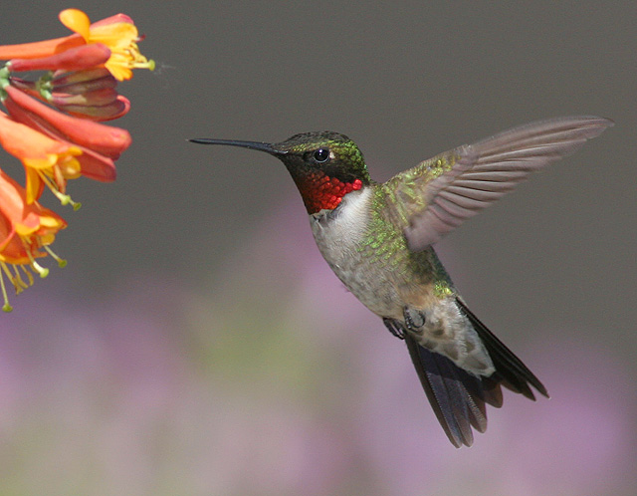

Welcome to the 16th of many newsletters from the world of birds. This will have fun facts and much more. We thank you for signing up to the newsletter and hope you are not disappointed by what you see here. Please email us if you have any inquires at theworldofbirdsoffical@gmail.com

31 for my top 35 most favourite birds is,

The Northern Lapwing, to find out more pay a visit to our website http://theworldofbirds.weebly.com
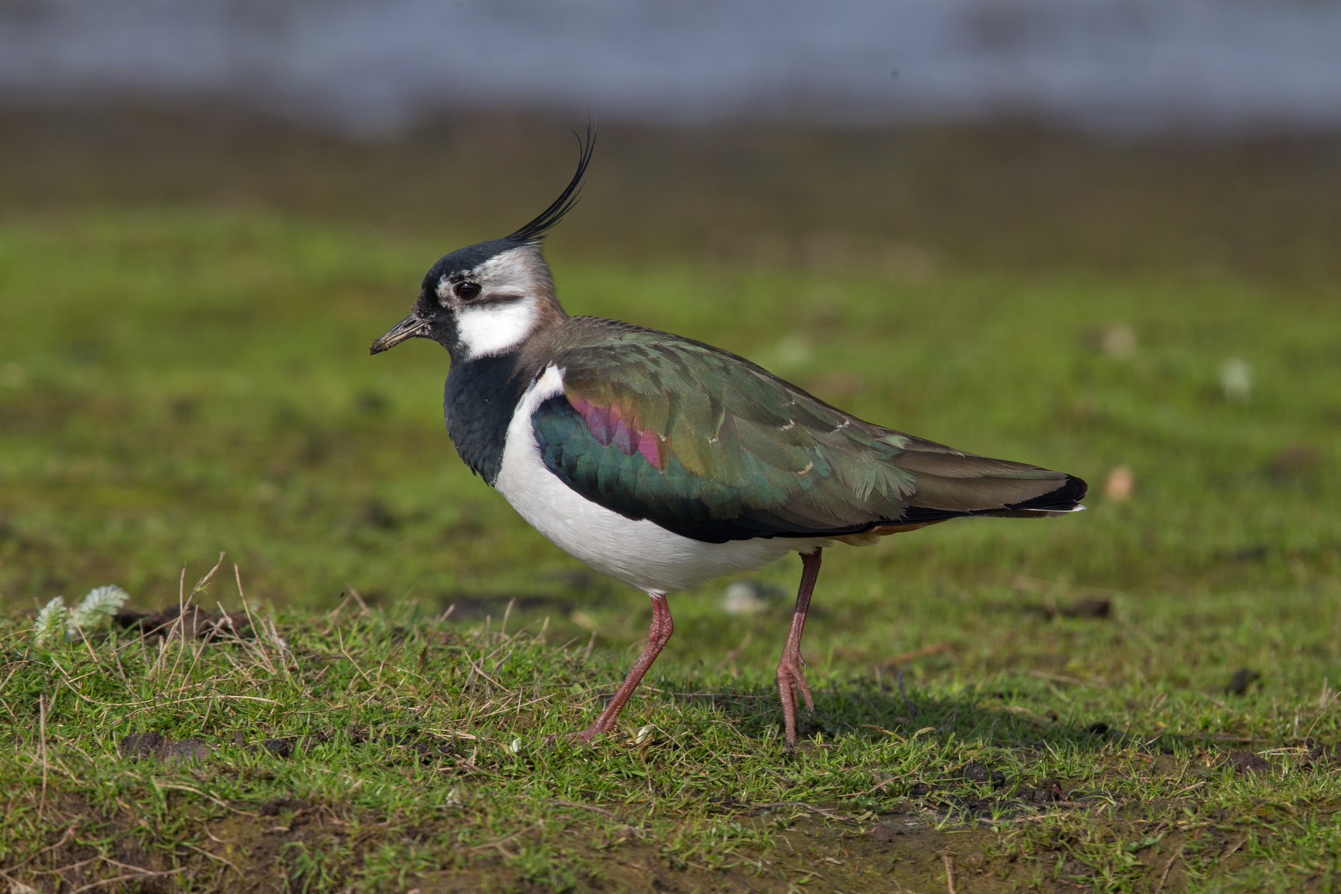
Birds seen this month!!!
- Coal tit Feral pigeons
- Ring-necked parakeet Magpie
- Jay Starling
- Black birds Gold crest
- Song thrush Black cap
- Great spotted woodpecker Green woodpecker
- Great tit Crow
- Dunnock Jackdaw
- Robin Collar dove
- Wren Nuthatch
- Chaffinch Sparrow hawk (male only)
- Goldfinch Siskin
- Greenfinch Pied wagtail
- Grey wagtail Long-tailed tit
- Tawny owl Stock Dove

Total: 30 species seen

Most seen bird of the month:
Feral Pigeon
Noisiest bird of the month:
Robin

Our migrants UPDATE!!!
We now also have 2 pairs of Black caps arrive to breed. We know they are nesting in the area. This is the first time we have had summer migrant Black caps visiting. We know that these aren’t the pair that winters here as we had a month between sightings of Black caps.
We now have 10 Swifts swooping around since Thursday 7th May. This is the latest we have had them arriving.
We also now have 3 Great Tit fledglings and One possibly two Blue Tit fledglings. Join us next issue to find out how many more fledglings have appeared.
Next Issue Join us For Summer migrant watch and fledgling count.
We would love you to join in with our winter migrant watch and Summer Migrant Watch. Go to our website to find out more. http://theworldofbirds.weebly.com
The Webcam should be up and running by the end of autumn (October/November) 2015 Sorry for any inconvenience!!!!

