iSSUE: 15

The World of birds

dATE: 5th may 2015

Welcome
qUiCK fACT

Did you know that the Eurasian Wren is the UK’s only species of Wren?

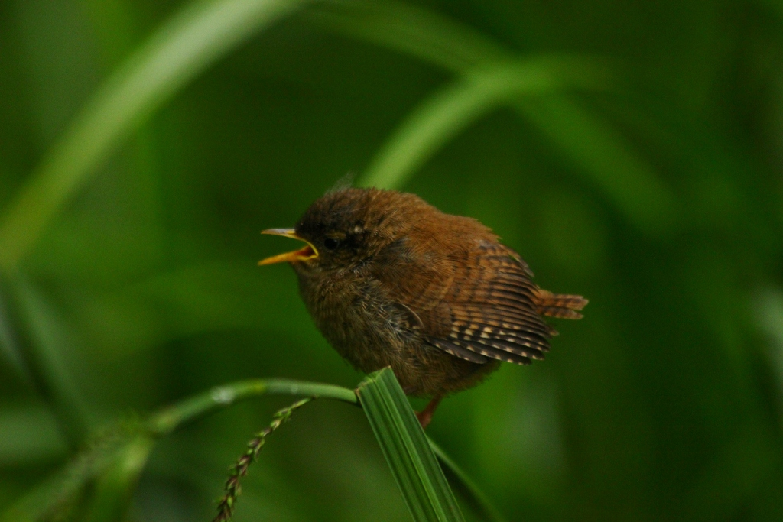

Welcome to the 15th of many newsletters from the world of birds. This will have fun facts and much more. We thank you for signing up to the newsletter and hope you are not disappointed by what you see here. Please email us if you have any inquires at theworldofbirdsoffical@gmail.com

30 for my top 30 most favourite birds is,

The Eurasian wren, to find out more pay a visit to our website http://theworldofbirds.weebly.com
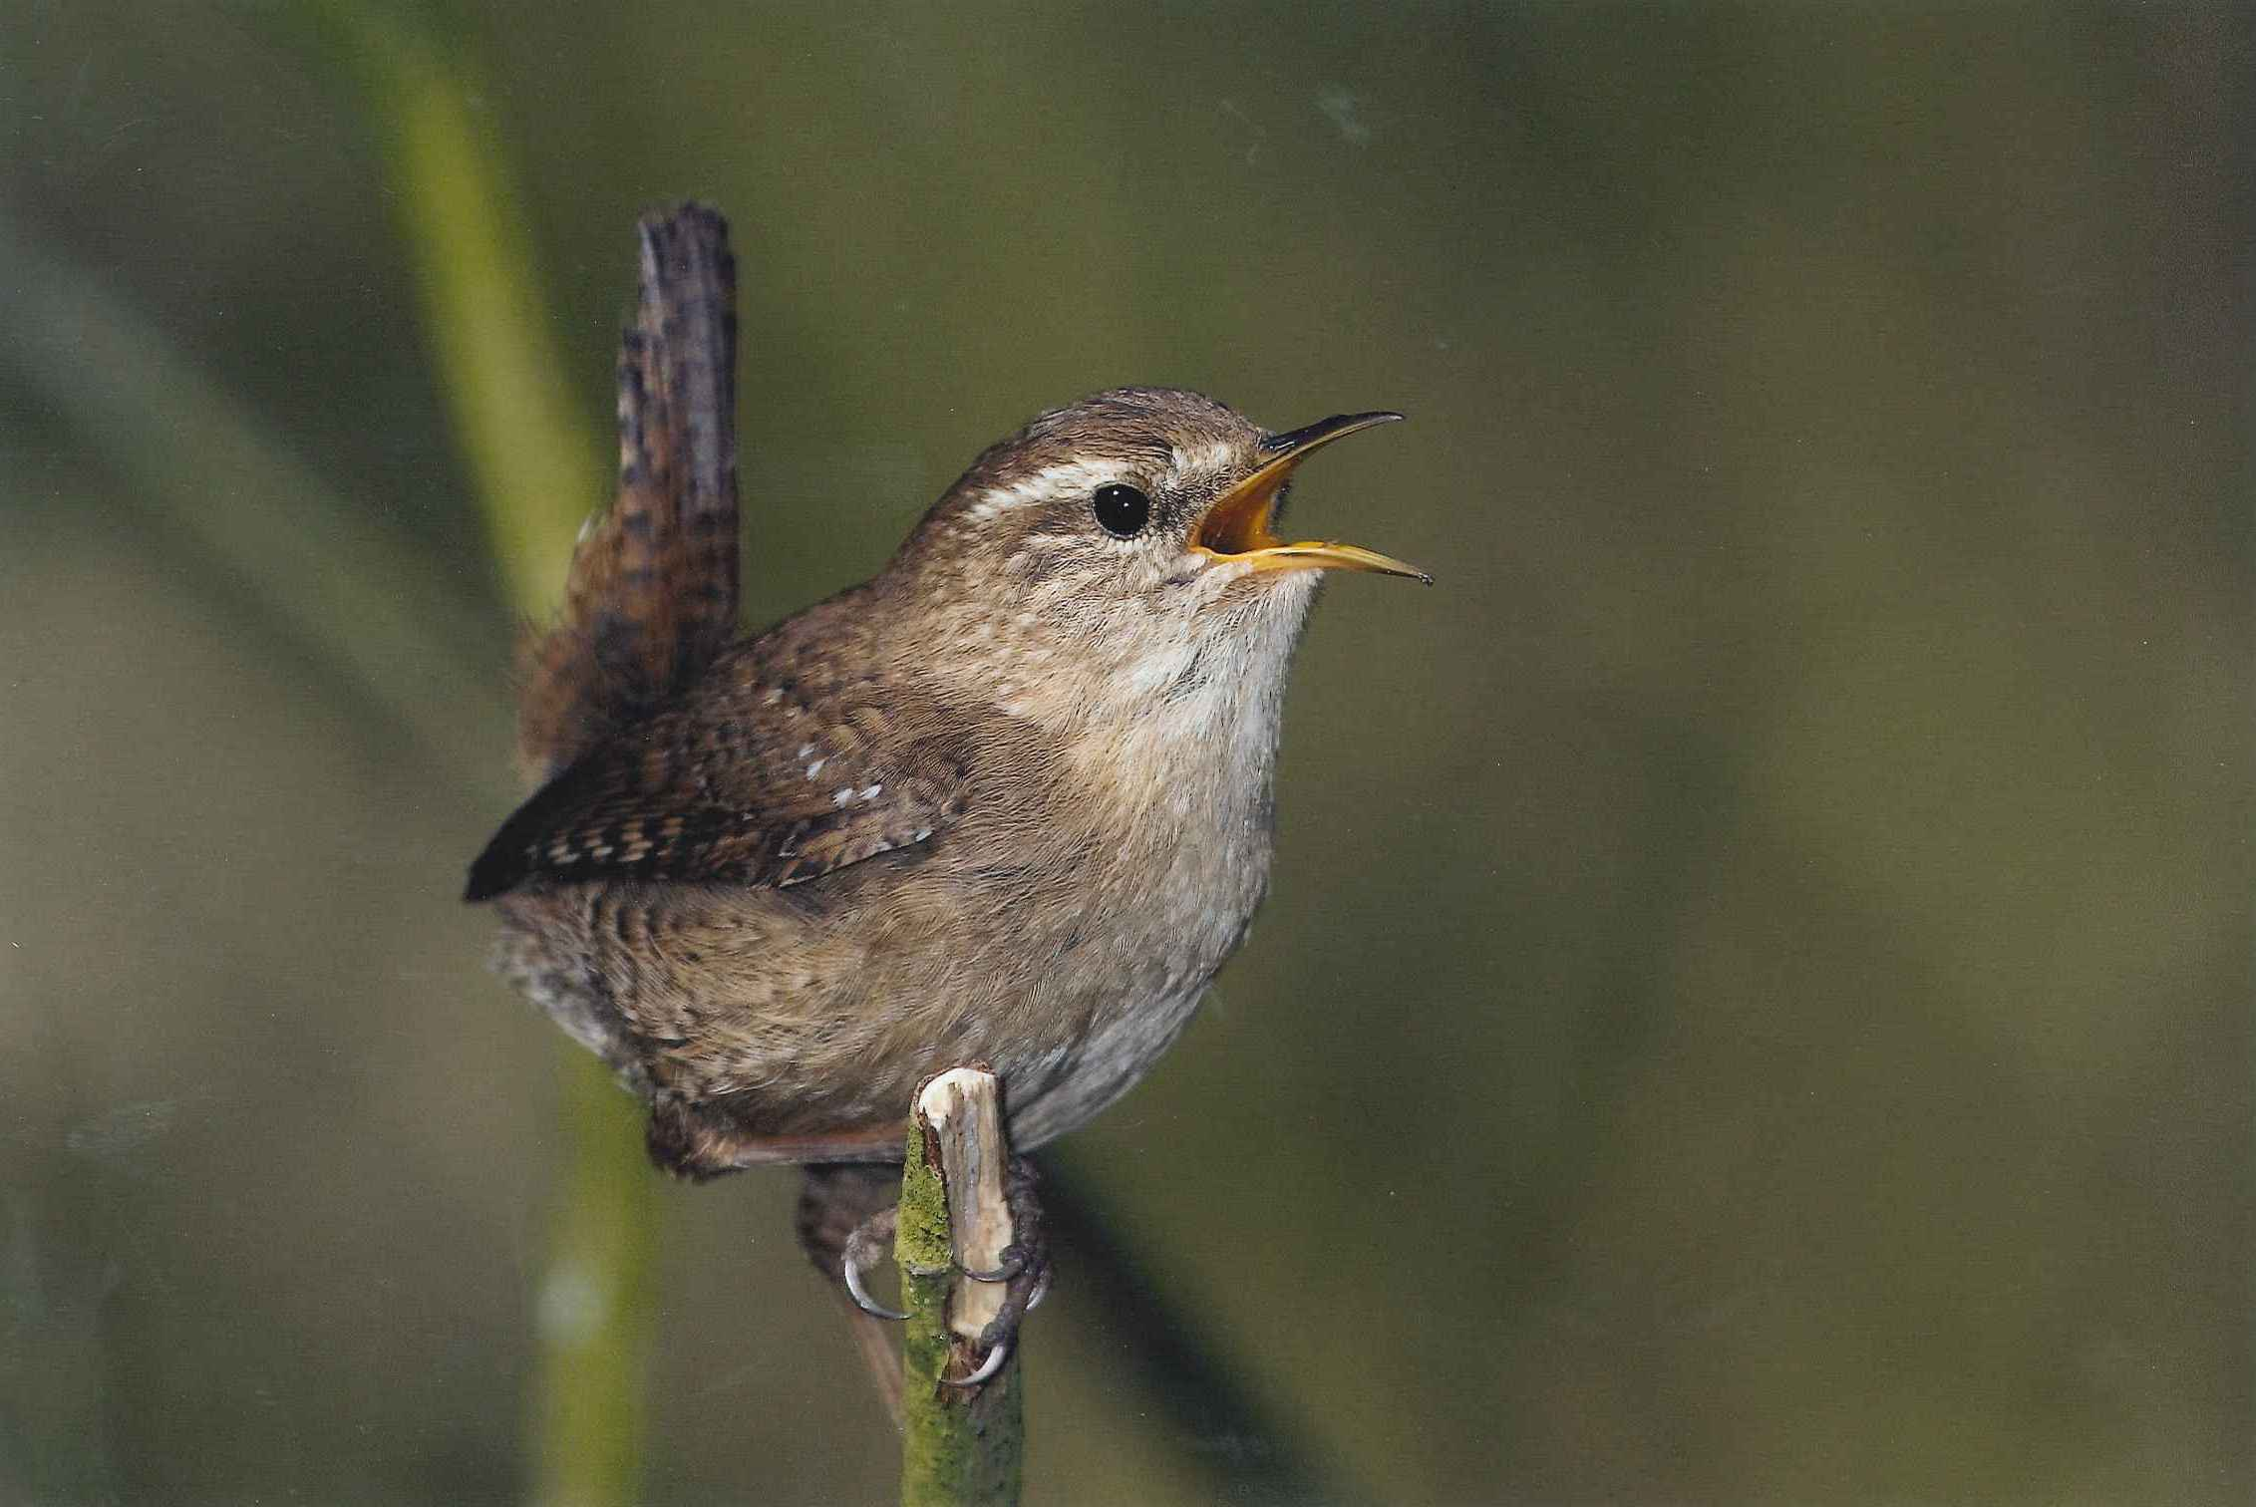
Birds seen this month!!!
- Coal tit Feral pigeons
- Ring-necked parakeet Magpie
- Jay Starling
- Black birds Gold crest
- Song thrush Black cap
- Great spotted woodpecker Green woodpecker
- Great tit Crow
- Dunnock Jackdaw
- Robin Collar dove
- Wren Nuthatch
- Chaffinch Sparrow hawk (male only)
- Goldfinch Siskin
- Greenfinch Pied wagtail
- Grey wagtail Long-tailed tit
- Tawny owl Stock Dove

Total: 30 species seen

Most seen bird of the month:
Blackcap
Noisiest bird of the month:
Ring-necked parakeet

Our migrants UPDATE!!!
We now also have 3 Starling which we think could be wintering however we won’t know until the spring to see if they stay or not.
Our Starling aren’t wintering, and there are now around 10 visiting the feeders every day. We know they are nesting as well and that they have chicks that will be ready to fledge in the next two weeks.
In other news we have had a return from the 3 collar dove’s and 2 green woodpeckers, and also a special arrival of 2 nesting Stock Dove. Photo’s to come soon.
We now also have 2 pairs of Black caps arrive to breed. We know they are nesting in the area. This is the first time we have had summer migrant Black caps visiting. We know that these aren’t the pair that winters here as we had a month between sightings of Black caps.
We are starting to get worried here at the world of birds as we have had no Swallows, House martins, or Swifts yet this year which is rather late. Hopefully by next issue they will have arrived.
Next Issue Join us For Summer migrant watch and fledgling count.
We would love you to join in with our winter migrant watch and Summer Migrant Watch. Go to our website to find out more. http://theworldofbirds.weebly.com
The Webcam should be up and running by the end of autumn (October/November) 2015 Sorry for any inconvenience!!!!

