iSSUE: 12

The World of birds

dATE: 24th JanuARY 2015

Welcome
qUICK fACT

Did you know that a group of owls is called a parliament???
This is a Little Owl!!!
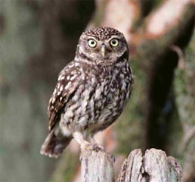

Welcome to the 12th of many newsletters from the world of birds. This will have fun facts and much more. We thank you for signing up to the newsletter and hope you are not disappointed by what you see here. Please email us if you have any inquires at theworldofbirdsoffical@gmail.com

27 for my top 25 most favourite birds is,

The Crested Tit, to find out more pay a visit to our website http://theworldofbirds.weebly.com
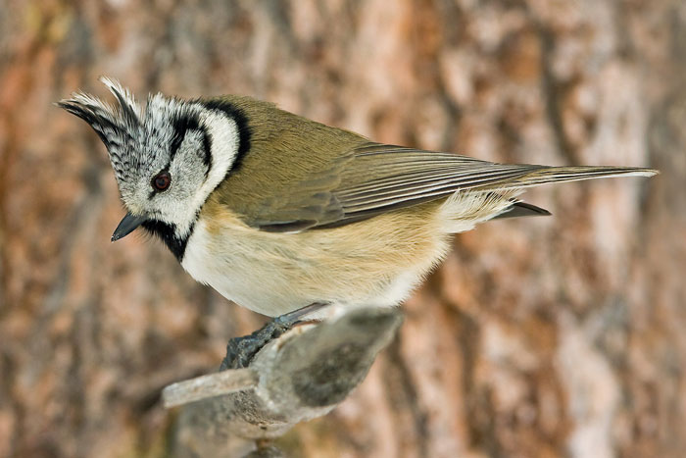
Most seen bird of the month:
Magpie
Noisiest bird of the month:
Great tit

Birds seen this month!!!
- Coal tit Feral pigeons
- Ring-necked parakeet Magpie
- Jay Starling
- Black birds Gold crest
- Song thrush Black cap
- Great spotted woodpecker Green woodpecker
- Great tit Crow
- Dunnock Jackdaw
- Robin Collar dove
- Wren Nuthatch
- Chaffinch Sparrow hawk (male only)
- Goldfinch Siskin
- Greenfinch Pied wagtail
- Grey wagtail Long-tailed tit
- Tawny owl

Total: 29 species seen

Our winter migrants UPDATE!!!
So far this year only one Redwing has returned from its summer vacation in Scandinavia. We are expecting as many as 29 more. Also for the last 2 weeks we have had a pair of Black Cap visiting the feeders, which we will be posting pictures and videos of on our website soon. We also have had a wintering song thrush, which has turned up. Unfortunately we don’t have any resident song thrushes any more as their population in the UK is declining at an alarming rate. This is thought to be due to habitat loss and people cutting down bushes too early after spring and exposing their nests and chicks.
We would love you to join in with our winter migrant watch. Go to our website to find out more. theworldofbirds.weebly.com
The Webcam should be up and running by April 2015 for any inconvenience!!!!

