iSSUE: 11

The World of birds

dATE: 21st December 2014

Welcome
qUICK fACT

Did you know that Kiwi Birds are blind and therefore hunt by smell?
This is a Kiwi.
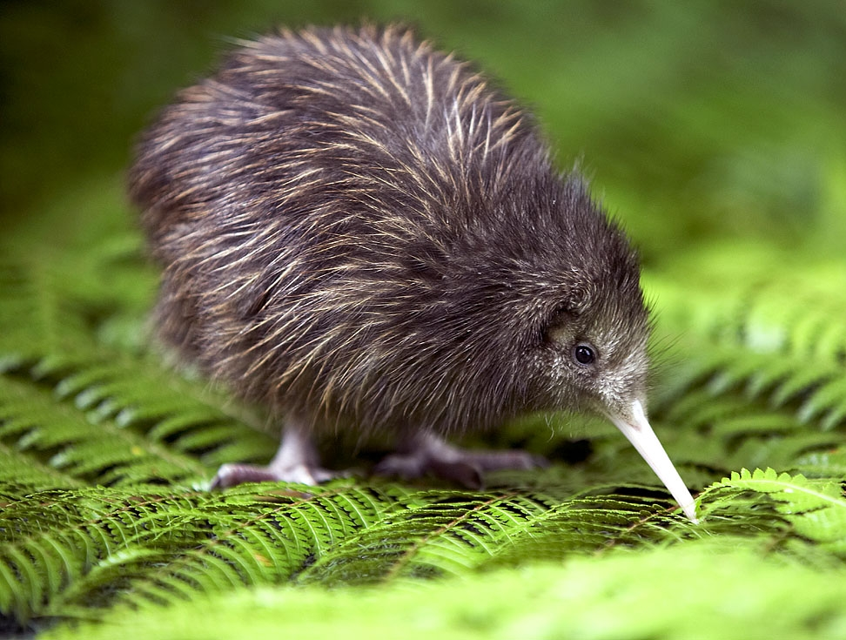

Welcome to the 11th of many newsletters from the world of birds. This will have fun facts and much more. We thank you for signing up to the newsletter and hope you are not disappointed by what you see here. Please email us if you have any inquires at theworldofbirdsoffical@gmail.com

26 for my top 25 most favourite birds is,

The Eurasian Black cap, to find out more pay a visit to our website http://theworldofbirds.weebly.com
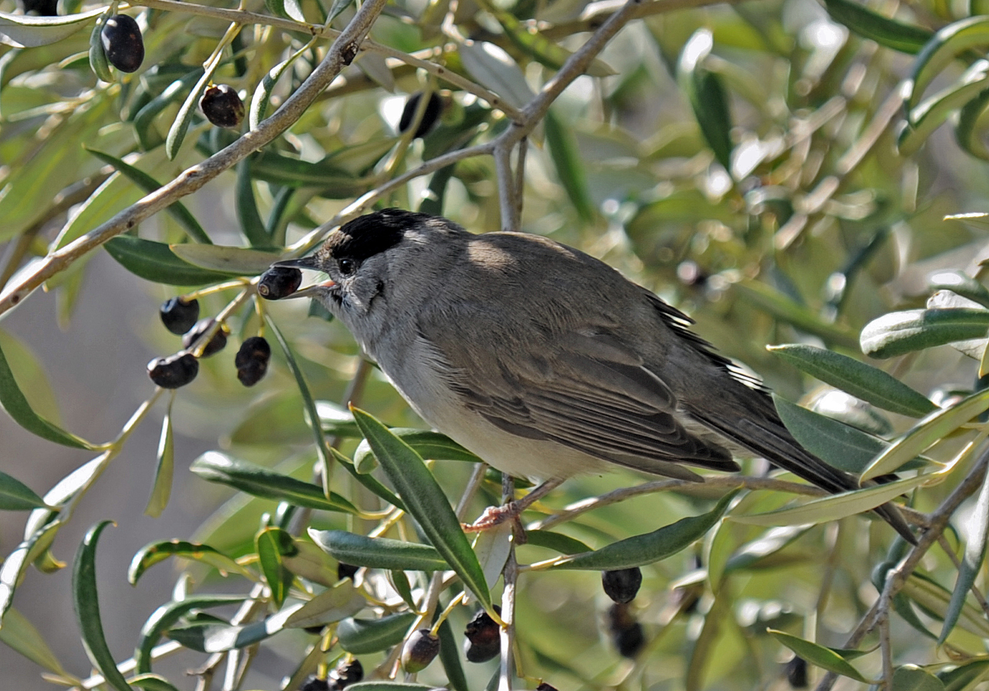
Most seen bird of the month:
Goldfinch
Noisiest bird of the month:
Ring-necked Parakeets

Birds seen this month!!!
- Coal tit Feral pigeons
- Ring-necked parakeet Magpie
- Jay Starling
- Black birds Gold crest
- Song thrush Black cap
- Great spotted woodpecker Green woodpecker
- Great tit Crow
- Dunnock Jackdaw
- Robin Collar dove
- Wren Nuthatch
- Chaffinch Sparrow hawk (male only)
- Goldfinch Siskin
- Greenfinch Pied wagtail
- Grey wagtail Long-tailed tit
- Tawny owl

Total: 29 species seen

Our winter migrants
So far this year only one Redwing has returned from its summer vacation in Scandinavia. We are expecting as many as 29 more. However every day that there are no easterly winds is another day that our winter migrants will be re planning their journey. Here are some of the pictures we have of our lovely loyal redwing. 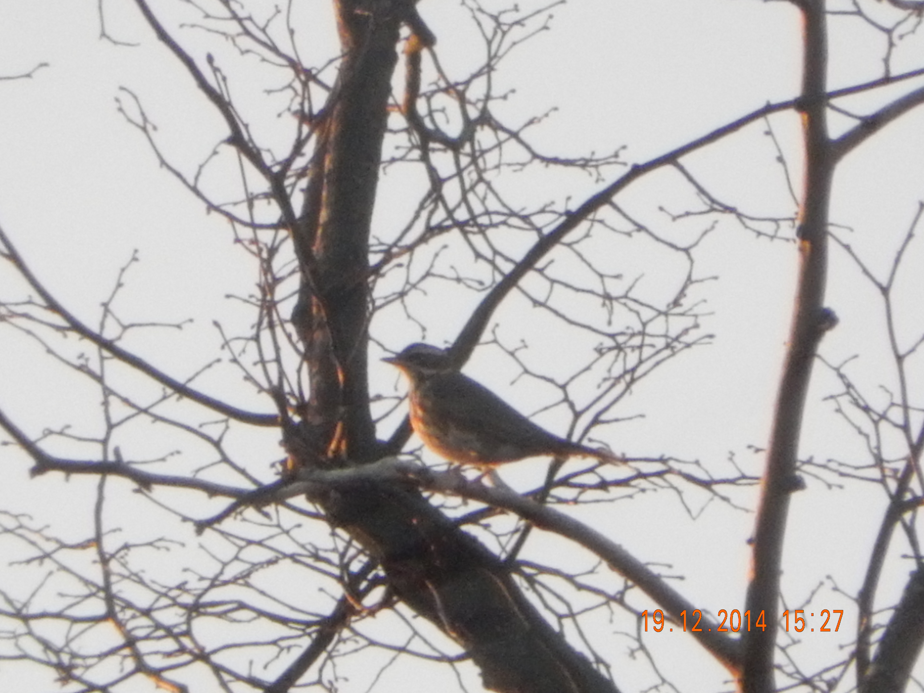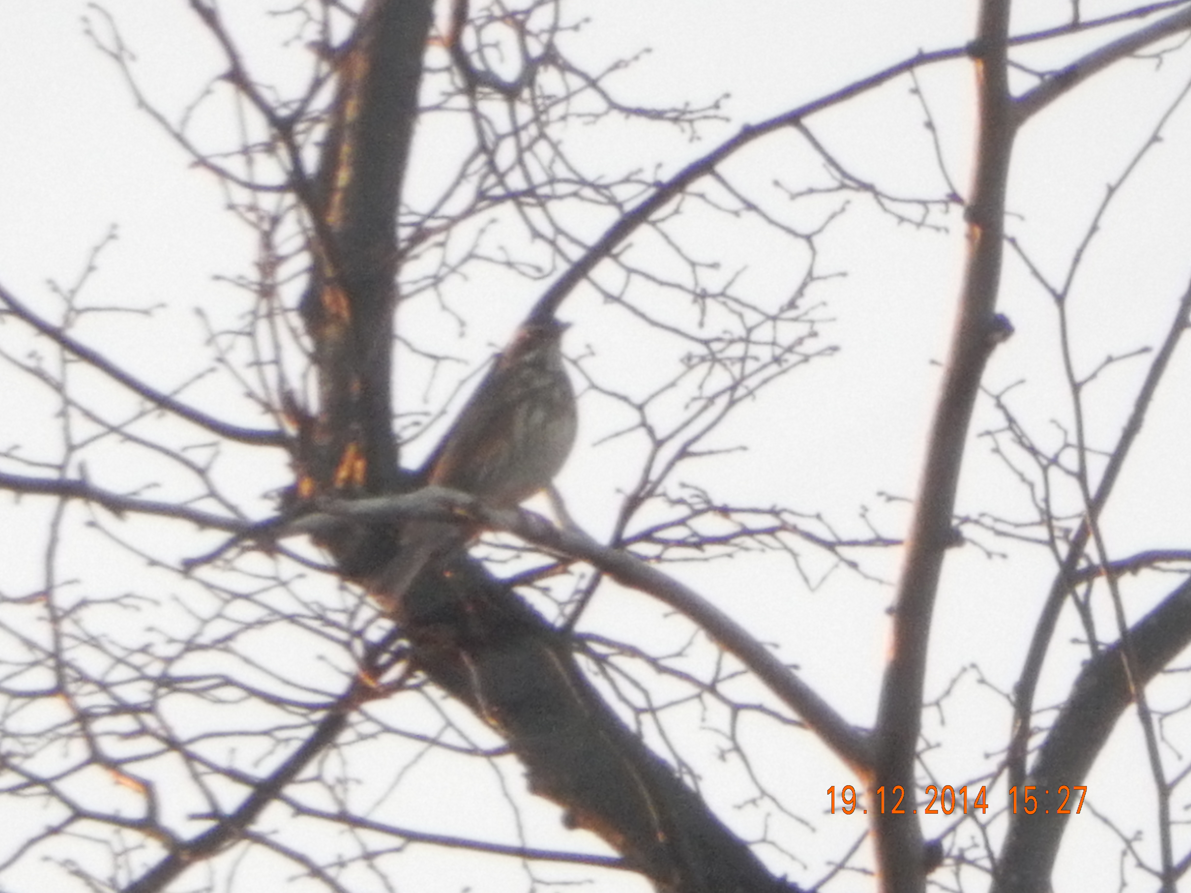
We would love you to join in with our winter migrant watch. Go to our website to find out more. theworldofbirds.weebly.com

The Webcam should be up and running by February 2015 for any inconvenience!!!!

