iSSUE: 10

The World of birds

dATE: 21st november 2014

Welcome
qUICK fACT

Did you know that the Hummingbird is the only bird that can fly backwards?

This is a Broad tailed hummingbird.
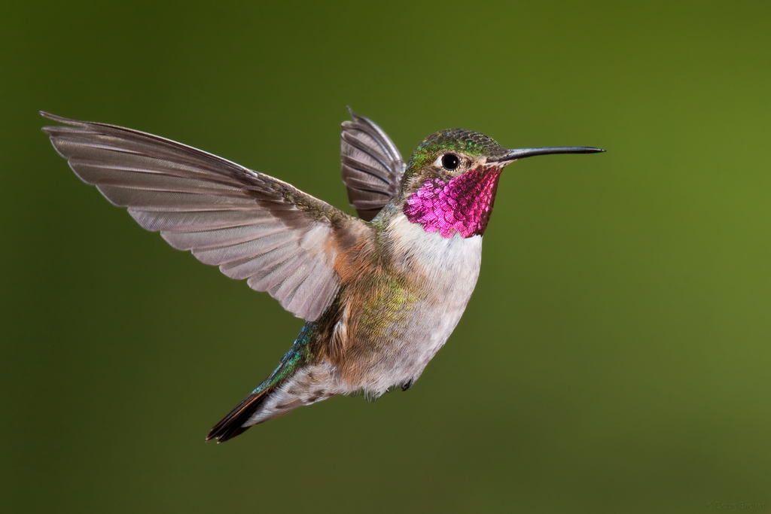

Welcome to the 10th of many newsletters from the world of birds. This will have fun facts and much more. We thank you for signing up to the newsletter and hope you are not disappointed by what you see here. Please email us if you have any inquires at theworldofbirdsoffical@gmail.com

24 for my top 25 most favourite birds is,

The Eastern Bluebird, to find out more pay a visit to our website http://theworldofbirds.weebly.com
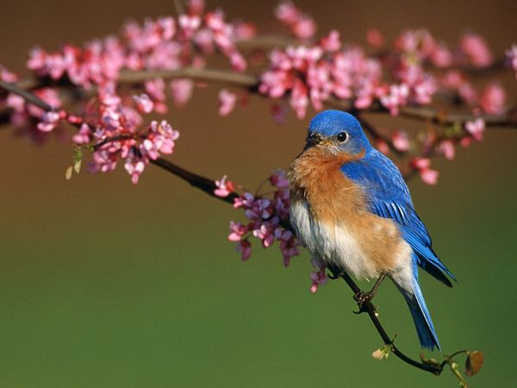
Birds seen this month!!!
- Coal tit Feral pigeons
- Ring-necked parakeet Magpie
- Jay Starling
- Black birds Gold crest
- Song thrush Black cap
- Great spotted woodpecker Green woodpecker
- Great tit Crow
- Dunnock Jackdaw
- Robin Collar dove
- Wren Nuthatch
- Chaffinch Sparrow hawk (male only)
- Goldfinch Siskin
- Greenfinch Pied wagtail
- Grey wagtail Long-tailed tit
- Tawny owl

Total: 29 species seen

Most seen bird of the month:
Goldfinch
Noisiest bird of the month:
Tawny owl

This issue is only short again as we are still waiting for our winter migrants to return (we have only had one Redwing return so far and we are expecting over 30). We cannot plan these things in advance meaning that we don’t have anything to write this issue on! Next month’s issue will have the new winter migrant’s watch providing they return. We would love you to join in with this too. Go to our website to find out more. theworldofbirds.weebly.com

The Webcam should be up and running by the end of the Year sorry for any inconvenience!!!!

