iSSUE: 1

The World of birds

dATE: 21ST DECEMBER 2013

Welcome
qUICK fACT

The smallest bird in England is the Gold crest, however this isn’t the smallest bird in the world as that falls to the Bee Hummingbird.

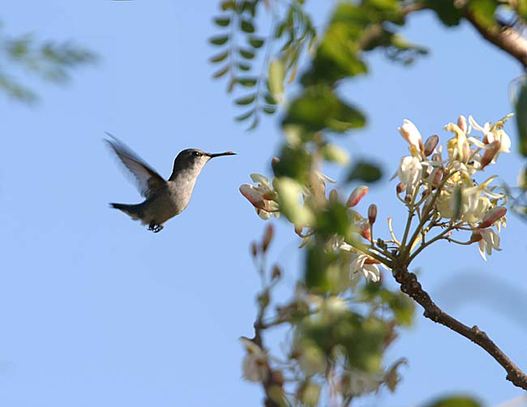

th
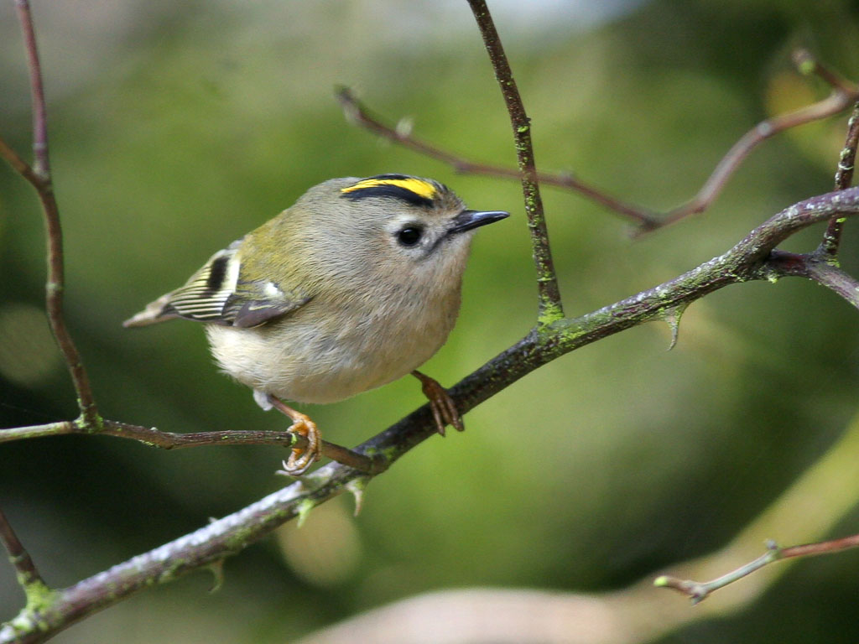

Welcome to the first of many newsletters from the world of birds. This will have fun facts and much more. We thank you for signing up to the newsletter and hope you are not disappointed by what you see here. Please email us if you have any inquires at theworldofbirdsoffical@gmail.com

14 for my top 15 most favourite birds is,

The sulphur-Crested cockatoo, to find out more pay a visit to our website http://theworldofbirds.weebly.com

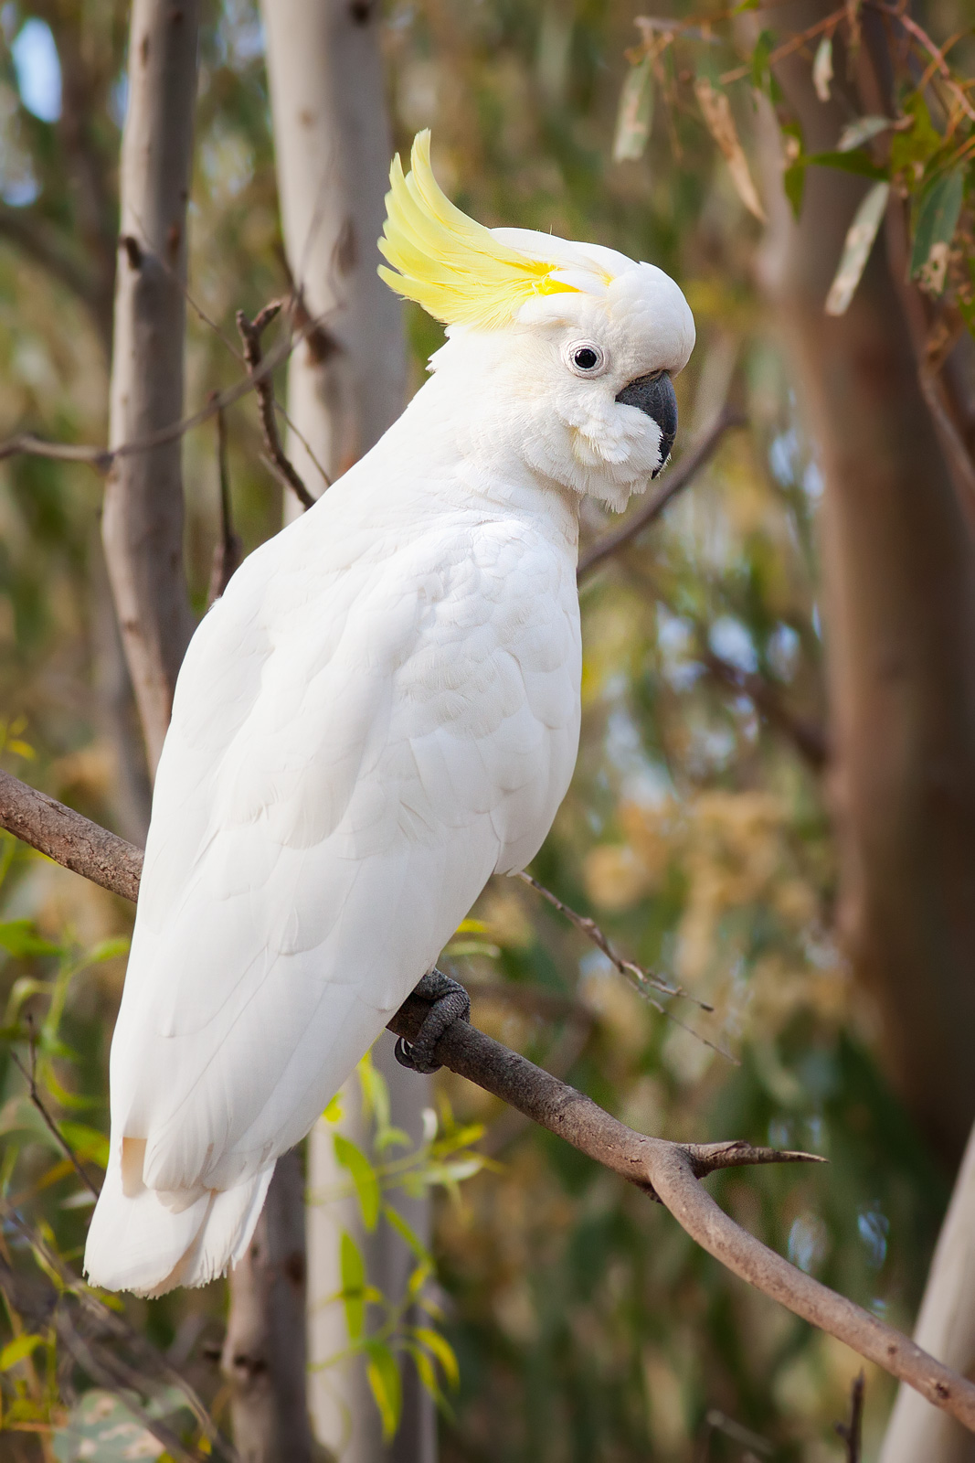
This is a Bee Hummingbird
Birds seen this month!!!
- Coal tit Feral pigeons
- Blue tit Wood pigeons
- Ring-necked parakeet Magpie
- Jay Starling
- Black birds Gold crest
- Song thrush Black cap (male only)
- Great spotted woodpecker Green woodpecker
- Great tit Crow
- Dunnock Jackdaw
- Robin Collar dove
- Wren Nuthatch
- Chaffinch Sparrow hawk (male only)
- Goldfinch Redwing
- Greenfinch Green woodpecker
- Pheasant Total: 29 species seen

Most seen bird of the month:
Blue tit
Noisiest bird of the month:
Ring-Necked parakeets

This is a Gold crest

